
Supertruck Celebration

SUMMARY:
Celebrate Stephen Savage's Supertruck, a picture book perfect for beginning readers, with activities, crafts, and more. Disguised as a quiet garbage truck, when a huge snowstorm hits the city Supertruck transforms to save the day! This overview outlines how to conduct this as a drop-in program, but it could easily be modified to be staff facilitated, which would be a wonderful opportunity to include a read aloud of the book.

BOOK TIE-IN:
- Supertruck by Stephen Savage
- Supertruck by Stephen Savage (bookpack)
  - Supertruck is an Early Book

CONDUCTING THE PROGRAM:
Welcome attendees when they enter the library. Invite them to take part in the program by doing one or all of the station activities. If possible, show them to the program space or show them the book. Have books available for check out in the program space. Check on the program throughout to tidy up, refresh supplies, and connect with caregivers and children as the day’s schedule allows.

- How will the program facilitator encourage meaningful interactions?
  - When stopping by the program space to tidy up and refresh supplies, program facilitator will introduce themselves to customers, ask about their projects, and encourage them to check out books.

- How will the program facilitator invite caregiver interaction with children?
  - Signs will be included at activity stations to prompt interactions.

Find information about GLR skills here.

Grade Level Reading Skills

Our goal is to create literacy-based programs for K-3rd graders to practice and gain confidence reading, and for the caregivers in their lives to learn about DPL tools and resources, as well as ways to foster family engagement beyond the library. Literacy-based programs include activities to support one or more of the GLR Skills. Literacy-based programs can take many forms (drop-in, time specific, etc.).

Insert activities or stations in the column’s they support:

Fluency | Background Knowledge | Comprehension | Reading Motivation | Decoding
- Listening station | - ​ | - Flannel board  - If I were a Truck  - Listening station | - Listening station  - Book display

Program Activities

Station 1: Listening Station
  - Skills Supported:
    - Fluency - Listening to the bookpack will model reading with fluency
    - Reading Motivation - Will increase awareness of bookpack collection
    - Comprehension - Sign will prompt caregivers to ask open-ended questions after listening
  - Activity: Have CD player and a copy of the bookpack for kids and caregivers to listen to and read along.
  - Setup: Secure a copy of the bookpack. Find a CD player and headphones, and a headphone splitter. Could also be done without headphones. Place the CD player, headphones, and book on a table along with a sign encouraging customers to listen and read along, and for caregivers to ask follow up questions after.

Station 2: Book Display
  - Skills Supported:
    - Reading motivation - Attendees will be able to check out additional reading
  - Activity: None
  - Setup: Find age appropriate materials about trucks, cities and snow and a surface to display them.

Station 3: Build a Truck
  - Skills Supported:
    - n/a
  - Activity: Attendees use paper shapes and glue to create paper trucks.
  - Setup: Cut out squares, circles, and rectangles from construction paper. Place in bins on table along with glue sticks, scissors, markers, and large pieces of construction paper to glue materials to. Include a sign and an example or two.

Station 4: Flannel Board
  - Skills Supported:
    - Comprehension - Attendees will retell or create their own Supertruck stories using flannel board pieces.
  - Activity: Attendees interact with a flannel board and felt trucks and skyscrapers to retell and create Supertruck stories.

  - Setup: Make felt board pieces by scanning, printing and laminating images from the book, or by creating felt versions of the truck and skyscrapers. Place a copy of the book nearby, along with a sign encouraging caregivers to read the book and retell it on the flannel board with their child.

Station 5: If I were a Truck Writing Prompt
  - Skills Supported:
    - Comprehension - Attendees will write and draw about the kind of truck they’d like to be and what their superpower might be, building on Supertruck’s disguise and superpower.
  - Activity: Attendees will write in their ideas about what kind of truck and their superpower they would want on a printable sheet. The sheet will have room for drawing a picture of your truck before and after changing into a hero.
  - Setup: Print If I were a Truck Template. Place on table with markers, crayons, and pencils. Along with a sign and examples.

Program Preparation
[Tasks to complete in advance for a successful program]

Budget:
- n/a

Books for Display:
- Supertruck by Stephen Savage
- Supertruck by Stephen Savage (bookpack)
- Potential display titles:
  - Good Morning, Snowplow! by Deborah Bruss
  - A Snowy Day by Ezra Jack Keats
  - Snow Day! by Candice Ransom
  - Snow Trouble by Melinda Crow
  - Duck, Duck, Dinosaur: Snowy Surprise by Kallie George
  - Max & Mo Make a Snowman by Patricia Lakin
  - Mixed Up Truck by Stephen Savage
  - Snow Sounds: An Onomatopoeic Story by David A. Johnson.
  - I Stink (and other titles in this truck series) by Kate McMullan
  - Nonfiction titles about trucks, snowplows, snow, and cities

Setup:

- You can use these station signs.
- You’ll need one table or flat surface for each station, except the flannel board, which can be propped against a wall.
- Print If I were a Truck templates.
- Cut construction paper into circles, squares, and rectangles.
- Place books on hold and/or gather from shelves.

Materials

REUSABLE MATERIALS:
  - Scissors
  - Markers
  - Colored pencils
  - Pencils
  - Sign holders
  - Flannel board
  - Sensory bin
  - Plastic cars
  - CD player
  - Headphones
  - Headphone splitter

DEPLETABLES:
  - Felt
  - If I were a Truck template
  - Glue sticks


PUBLIC LIBRARY
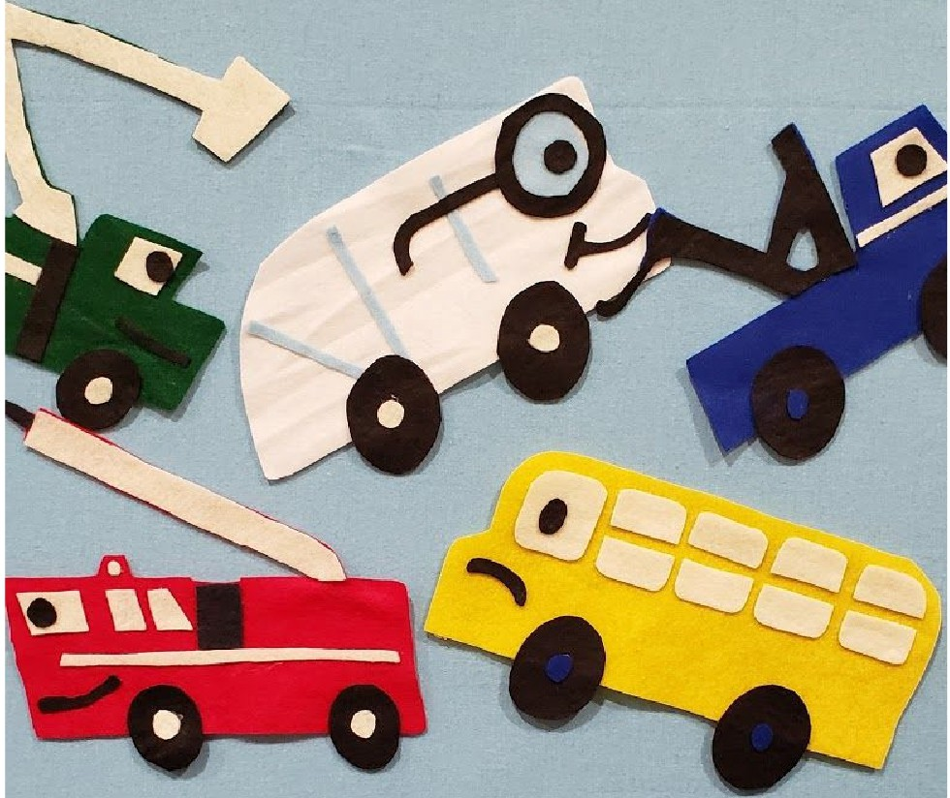
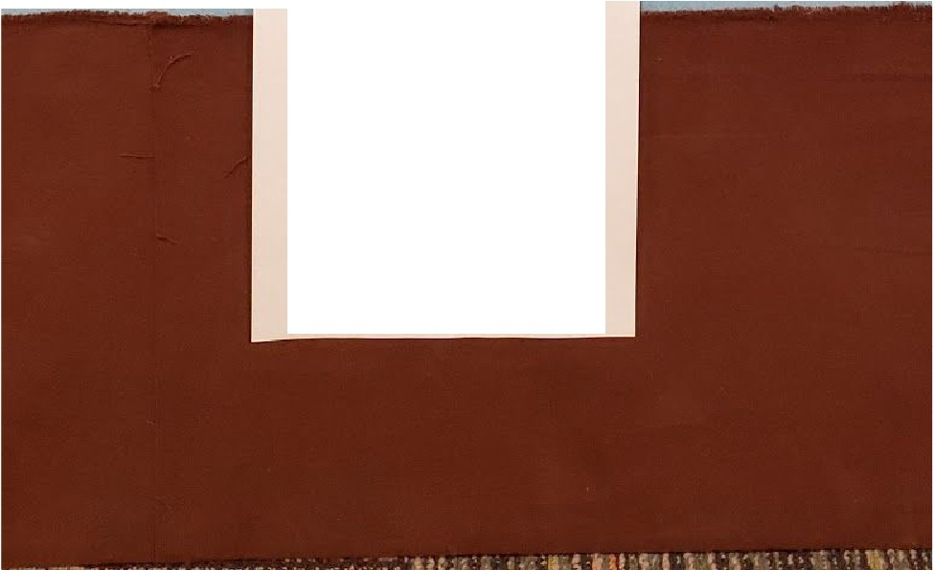
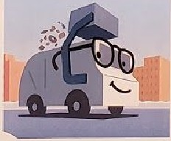
Retelling a story is a great way to build comprehension skills, so important for developing readers.
Retell or Create Your Own Supertruck Story

liK PUBLIC
LIBRARY
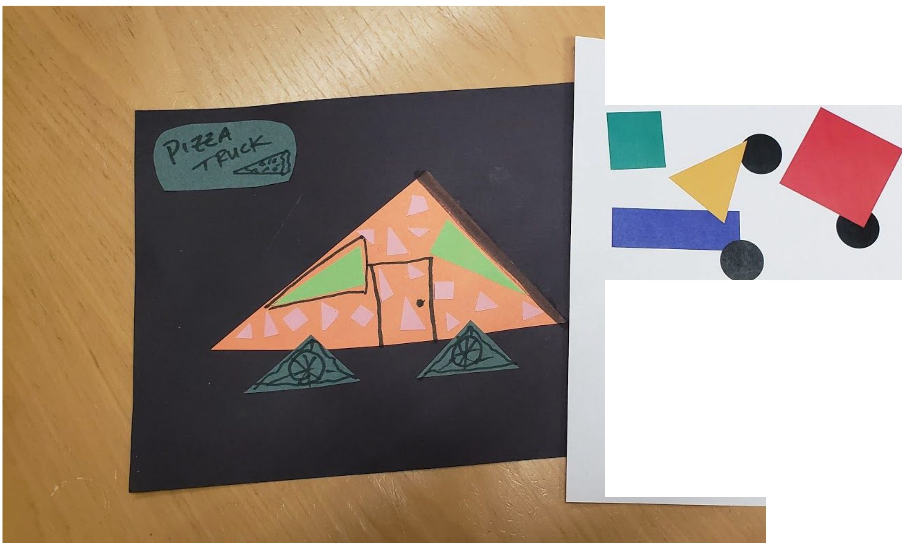
Build a Truck
Use shapes to create trucks or other vehicles.
Shapes are the building blocks of letters.

