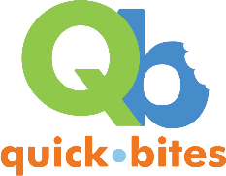
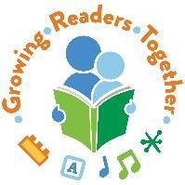
Process Over Product:

Explore the Magic of Open Ended Creativity
with Melody Garcia: GRT Early Literacy Specialist
garcia_m@cde.state.co.us

If you can make a mess, try:
Painting without brushes sticks or flowers Q-tips
puff balls yarn
toys (cars, dinosaurs, etc.)
Painting without paint
mashed berries
condensed milk, edible finger paint ice cubes/ water
Eye droppers with liquid watercolors on coffee filters
milk
shaving cream

What if there was NO product?
Shadow art Collaborative art
Dough (create, smash, repeat)
Loose parts (arrange, sort, stack, mix) Spaghetti painting
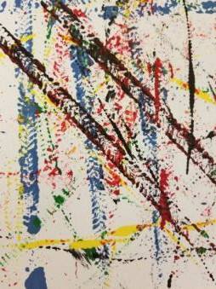
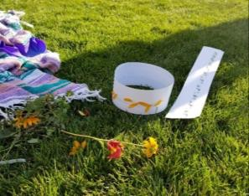
Shaving cream marbling Ice painting

Less mess, just as much process:
Collage
shapes tissue paper
dot/ star stickers leaves/ flowers
Different mediums
contact paper sand paper tin foil
Dough
salt dough
DIY play dough Stamping
vegetables/ fruits toy footprints leaves/ flowers cardboard tubes

Useful supplies:
TARPS!
Trays (cookie sheets, platic serving trays) Clipboards
Paint Pallets
Smocks (Directions for DIY Tshirt Smocks) Tempra Paint
Washi Tape Eye Droppers
Liquid Water Colors
Sentence Strips & Double Sided Tape Contact Paper

Websites with Great Ideas:
Library Makers: Toddler Art Class: Madison Public Librarian, Carissa Christner, shares her process art programs, with picture book tie-ins http://librarymakers.blogspot.com/search/label/Toddler%20Art%20Class

Fun at Home with Kids: Asia Citro (also the author of Zoey and Sassafras) has great ideas on her website and her other books
https://www.funathomewithkids.com/
Her list of 50 Process Art Ideas from around the web: https://www.funathomewithkids.com/2015/06/50-easy-process-art-activities-for-kids.html?m=1

Fun-a-Day: ECE teacher resources with a focus on process art
https://fun-a-day.com/category/playful-learning/art/

Pinterest: Follow me or discover other Process Art boards https://www.pinterest.com/melodyjoy9/process-crafts-for-storytime/

Talking about Process Art:

With the young artist:
“Can you tell me about your art?”
“I notice you’re using a lot of ” “How does that feel on your hands?”
“What did you enjoy most about your creation?”

With a caregiver:
who wants to stop the artist:
“What if we just pause and take a photo? Your child is really enjoying/ discovering/ engaged in the process of , and that experience is why we’re here today.” who what to help the artist:
“There is no right way to engage with the materials. They may not want to today, but they are learning by exploring the materials.”

who wants to better understand process art:
“Process art allows children to enjoy the creation of art without worrying about what the result should be. They get to explore and discover and sometimes what they make is amazing, but it’s the experience that matters.”

