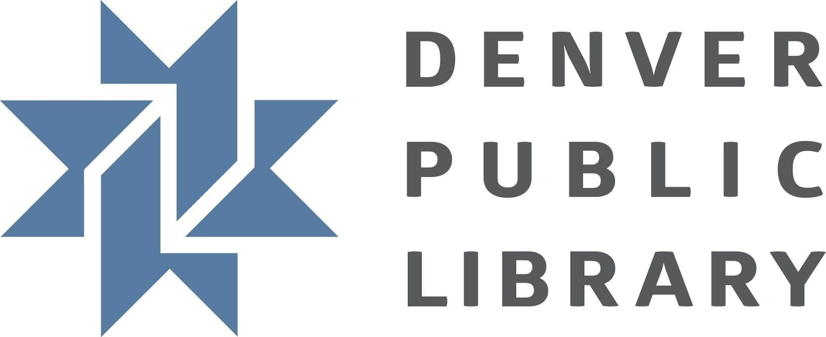
Narwhal and Jelly Celebration

SUMMARY:
Great for groups of any size, this program is based around the Narwhal and Jelly series titles with the goal of getting kids excited and motivated to read. This overview outlines how to conduct this as a staff facilitated program, however it can be easily modified to a drop-in program by eliminating the read aloud portion and instead focusing on the hands-on activities.

BOOK TIE-IN:
- Narwhal: Unicorn of the Sea by Ben Clanton
- Super Narwhal and Jelly Jolt by Ben Clanton
- Peanut Butter and Jelly by Ben Clanton
  - Narwhal and Jelly series titles are Transitional Books

CONDUCTING THE PROGRAM:
Welcome attendees on the way in. Invite them to explore display books while they wait for the program to begin. Share one or more of the books. Depending on the group you might read a whole book(s) or just parts. Intersperse reading with a few ocean animal jokes, an ocean animal song or two or ask open-ended questions about the characters, settings and plot. After reading for a bit (10-20 min) move onto hands-on activities.

- How will the program facilitator encourage meaningful interactions?
  - During the book share, the program facilitator will model how to ask open-ended questions to build comprehension skills.
  - During the book share, the program facilitator will include jokes and songs/rhymes that encourage rhyming skills and wordplay.
  - While children are doing hands-on activities, the program facilitator will ask questions that invite children to retell stories.

- How will the program facilitator invite caregiver interaction with children?
  - During the hands-on activities portion the program facilitator will encourage caregivers and children to explore Narwhal and Jelly titles, as well as other related books, to inspire discussion and curiosity.

Find information about GLR skills here.

Grade Level Reading Skills

Our goal is to create literacy-based programs for K-3rd graders to practice and gain confidence reading, and for the caregivers in their lives to learn about DPL tools and resources, as well as ways to foster family engagement beyond the library. Literacy-based programs include activities to support one or more of the GLR Skills. Literacy-based programs can take many forms (drop-in, time specific, etc.).

Insert activities or stations in the column’s they support:

Fluency | Background Knowledge | Comprehension | Reading Motivation | Decoding
- Book share | - Make a narwhal tusk tooth  - Make a jellyfish | - Book share  - Write your own comic | - Book share  - Book display

Program Activities

Station 1: Book share
  - Skills Supported:
    - Fluency - Singing or chanting ocean animal songs and rhymes.
    - Reading motivation - Reading and booktalking titles will motivate attendees to explore the topic further.
    - Comprehension - Asking open-ended questions about the characters, setting and plot.
  - Activity: Share one or more of the books (partially or wholly) with the group
  - Setup: Secure copies of the books and bring to the program. Use sticky notes to flag sections for sharing.

Station 2: Book Display
  - Skills Supported:
    - Reading motivation - Attendees will be able to check out additional reading
  - Activity: None
  - Setup: Find age appropriate materials and a surface to display them.

Station 3: Make a Narwhal Tusk Tooth
  - Skills Supported:
    - Background Knowledge - Attendees will learn and explore narwhal anatomy vocabulary (tusk tooth, etc.), as well as facts about narwhals.
  - Activity: Attendees cut out, assemble, and decorate a tusk tooth they can wear on their heads.
  - Setup: Print tusk tooth template on cardstock. Provide scissors, hole punches, elastic, tape, markers and other decorations.

Station 4: Make a Jellyfish
  - Skills Supported:
    - Background Knowledge - Attendees will learn and explore jellyfish anatomy vocabulary (tentacles, etc.), as well as facts about jellyfish.
  - Activity: Attendees make a jellyfish out of ribbons and a paper plate.
  - Setup: Provide paper bowls, scissors, tape, markers and other decorations.

Station 5: Write Your Own Comic
  - Skills Supported:
    - Comprehension - Attendees will retell or create their own Narwhal and Jelly comic using images and/or words.
  - Activity: Attendees use pencils and templates to create comics.
  - Setup: Print comic template. Provide pens and colors pencils.

Station 6: Eat a Waffle
  - Skills Supported:
    - None
  - Activity: Attendees eat waffles. Waffles are Narwhal’s favorite food.
  - Setup: Purchase pizzelle cookies from King Soopers. Provide paper plates and napkins.

Program Preparation
[Tasks to complete in advance for a successful program]

Budget:
- $20 for pizzelle cookies and sundry supplies

Books for Display:
- Narwhal and Jelly series titles by Ben Clanton
- Nonfiction books about narwhals and jellyfish
- More books by Ben Clanton

Setup:

- You can use these station signs.
- You could easily do this program without the book share activity, but the book share is a great way to give all attendees context and knowledge of the characters and stories. Comics created after the book share were much more creative than those created during a drop-in session that did not include a book share.
- Get the vanilla pizzelles, rather than the anise if possible. They seem to please more taste buds.
- It would be fun to make flannel board characters for kids to retell the story in another way.

Materials

REUSABLE MATERIALS:
  - Scissors
  - Hole punches
  - Markers
  - Colored pencils
  - Pens
  - Acrylic sign holders (optional)
  - Book easels for display (optional)

DEPLETABLES:
  - Elastic string (12” for each tooth tusk)
  - Ribbons
  - Pizzelle cookies
  - Paper plates
  - Paper napkins
  - Paper bowls
  - comic template
  - tusk tooth template

