Leading with Emotional Intelligence:
Become an Emotion Scientist


"scientist-minifig" by pixbymaia is licensed under CC BY-NC-SA 2.0

Amy Shipley | Director | Basalt Regional Library
Christine Kreger | Professional Development Consultant | Colorado State Library

How are you feeling today? (No, really…How are you feeling?)

Self-Assessment
Rate yourself on each statement from 1-10, with 10 being the highest.
You will not need to compute a score, just rate yourself on the items
Personal competence - how we manage ourselves
Self-awareness - knowing one's internal states, preferences, resources, and intuitions
- Emotional awareness - Reading one’s own emotions and recognizing their impact; using “gut sense” to guide decisions
- Accurate self-assessment - knowing one's strengths and limits
- Self-confidence - a sound sense of one's self worth and capabilities
Self-regulation - managing one's internal states, impulses, and resources
- Emotional Self-control - keeping disruptive motions and impulses under control
- Transparency - Displaying honesty and integrity; trustworthiness
- Adaptability - Flexibility in adapting to changing situations or overcoming obstacles
- Achievement - The drive to improve performance to meet inner standards of excellence
- Initiative - Readiness to act and seize opportunities
- Optimism - Seeing the upside in events

Social Competencies - determine how we manage relationships

Social Awareness - an awareness of others’ feelings, needs and concerns

- Empathy - sensing other’s feelings and perspectives and taking an active interest in their concerns
- Organizational awareness - Reading the currents, decision networks, and politics at the organizational level
- Service - Recognizing and meeting follower, client, or customer needs

Social skills - adeptness at inducing desirable responses in others

- Inspirational leadership - Guiding and motivating with a compelling vision
- Influence - Wielding a range of tactics for persuasion
- Developing others - Bolstering others’ abilities through feedback and guidance
- Change catalyst - Initiating, managing, and leading in a new direction
- Conflict management - Resolving disagreements
- Teamwork and collaboration - Cooperation and team building
- Building Bonds – Cultivating and maintaining a web of relationships

The Science of Emotions
The limbic system refers to the set of structures in the brain that plays an important role in emotional regulation and is responsible for the regulation of autonomic and endocrine function in response to emotional stimuli. It is made up of four main parts: the thalamus, the amygdala, the hippocampus, and the hypothalamus.

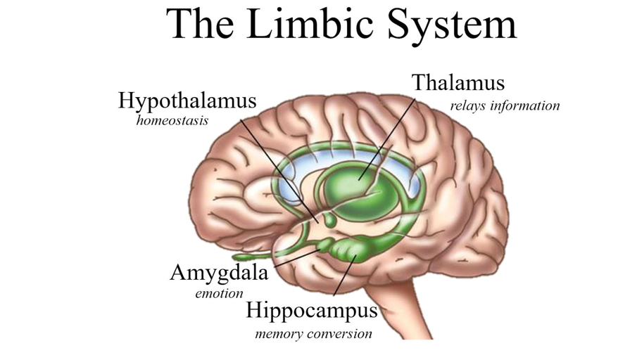

Prefrontal Cortex

https://ysjournal.com/the-emotional-brain/
Thalamus - collects sensory inputs (visual, auditory, and somatosensory) and relays these inputs to the amygdala and higher cortical regions for processing.
Amygdala - collects sensory inputs from the thalamus and stimulates the hypothalamus to release hormones.
Hypothalamus - regulates the autonomic nervous system (ANS) by regulating the endocrine system which is involved in the release of different hormones into the bloodstream. The ANS controls the reflexive physiological changes that occur in response to emotional stimuli (breathing, heart rate, blood pressure, temperature).
Hippocampus - processes long-term memory and emotional responses. Emotion and memory are closely linked, and future decision-making is frequently based upon emotions tied to past experiences.
Prefrontal cortex – is our command center helping guide our actions. Linked to higher order thinking, the prefrontal cortex helps us process our emotions and decide what to do next.

The Importance of Emotions

Emotional Intelligence Core Elements

Recognition/Awareness
S  e  l  f | Self-Awareness  Emotional self-awareness  Accurate self-assessment  Self-confidence | Social Awareness | O  t  h  e  r  s
  Empathy
  Organizational Awareness
  Service
S  e  l  f | Self-Management | Relationship Management  Influence  Inspirational Leadership  Developing Others  Change Catalyst  Building Bonds  Conflict Management  Teamwork & Collaboration | O  t  h  e  r  s
  Emotional Self-Control
  Transparency
  Adaptability
  Achievement
  Initiative
  Optimism
Regulation/Control
https://ohio4h.org/sites/ohio4h/files/imce/Emotional%20Intelligence%20Background.pdf
Self-Awareness

RULER
R: _______________ emotions in oneself and others
U: _______________ the causes and consequences of emotions
L: ________________ emotions with a nuanced vocabulary
E: ____________________ emotions in accordance with cultural norms and social context
R: ________________emotions with helpful strategies

Mood Meter/ Mood Meter App - http://moodmeterapp.com/

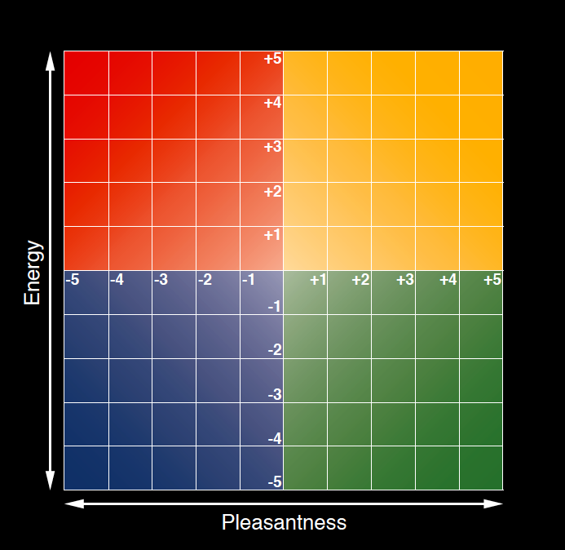
https://www.marcbrackett.com/the-colors-of-our-emotions/
Mood Wheel
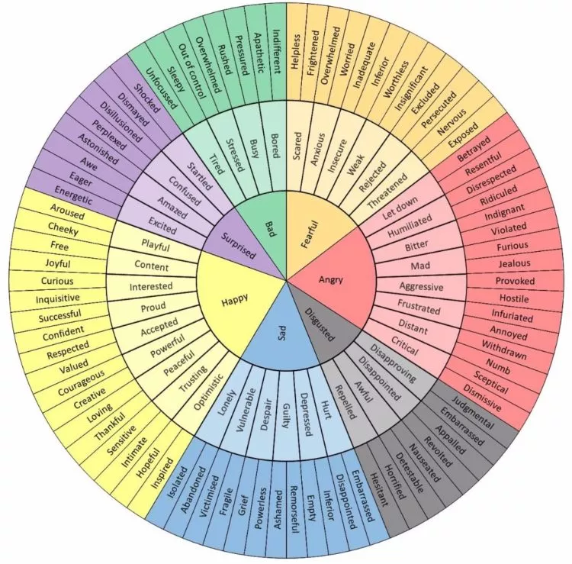
https://themighty.com/2020/09/charts-to-help-identify-emotions-mental-health/

Self-Management/Self-Regulation

Meta Moment
Marc Bracket recommends taking time to pause, or to take a Meta Moment as we express our emotions. To literally think about our emotions.

- Here is what I feel and why
- Here is what I want to happen next
- Here is what I need from you right now

“A view of human nature that ignores the power of emotions is sadly shortsighted.”
– Daniel Goleman

Social Awareness/Empathy

Empathy Map
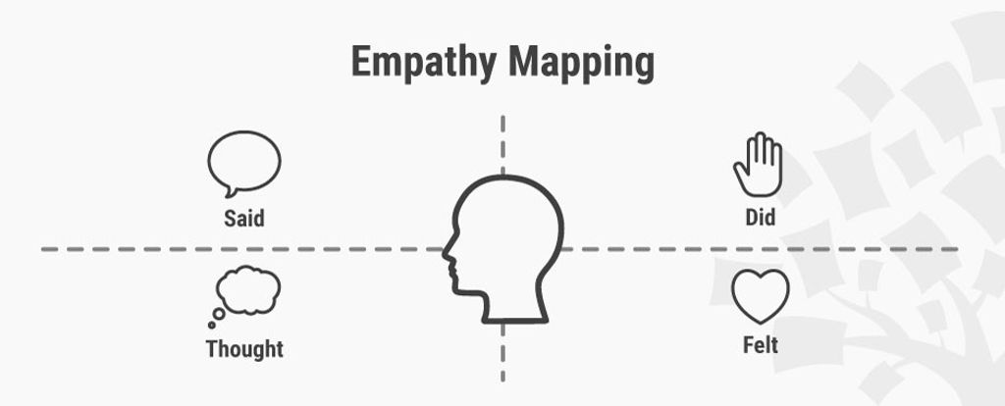
https://www.interaction-design.org/literature/article/empathy-map-why-and-how-to-use-it

“With emotion skills, we create a more inclusive, compassionate, and innovative world.”
– Marc Brackett

Relationship Management

Listening and Asserting Skills

Listening Skills | Asserting Skills
Releasing  - Temporarily suspend your agenda  - Be open-minded; consider other views  - Don’t interrupt; be patient | Clarifying Intentions  - Be clear about your goals and needs
Attending  - Orient your body toward the other  - Maintain appropriate eye contact  - Be sensitive to incongruence in the speaker’s verbals and nonverbals | Remaining Centered  - Be poised – neither defensive nor aggressive  - Remain emotionally balanced
Amplifying  - Encourage the other to continue  - Inquire--ask clarifying questions  - Find common ground | Expressing  - State your position clearly  - Avoid vague words or qualifiers  - Use a confident tone of voice
Reflecting  - Summarize  - Paraphrase and link perspectives  - Contrast or differ constructively  - Note the speaker’s feelings | Supporting  - Use strong, definitive gestures  - Use appropriate eye contact  - Maintain steady, assured posture
Persisting
- Have the courage to persevere
- Be resolved but open to collaboration

Uroda, Kathy, et al. Leadership Through Influence. Lore International Institute, 2008.

Scenario
You are facilitating a meeting with library staff from across Colorado, and one member is bullying other members.
You do not know any of the attendees well.
How would you use your strongest Core Element to address this behavior, either during the meeting, or after the meeting with the bully, or with the person being bullied, or both?
You may find the Emotional Intelligence Competencies listed below helpful.

Emotional Intelligence Competencies
Self-Awareness
Emotional Awareness Competence - reading one's own emotions and recognizing the impact using gut sense to guide decisions

- Know which emotions we are feeling and why
- Realize the links between feelings and what we say, think, and do
- Recognize how feelings affect performance
- Have a guiding awareness of values and goals

Accurate Self-Assessment Competence - knowing one's strengths and limitations

- Aware of strengths and weaknesses
- Reflective, learns from experience
- Open to candid feedback, new perspectives, continuous learning, and self-development
- Able to show a sense of humor and perspective about self
- Aware of blind spots
- Required alignment between personal values and those of the org

Self-Confidence Competence - a sound sense of one’s self worth and capabilities

- Present self with self-assurance; have presence
- Voice views that are unpopular and go out on a limb for what is right
- Decisive, able to make sound decisions despite uncertainties and pressures

Self-Management/Self-Regulation
Emotional Self-Control Competence - keeping disruptive emotions and impulses under control
- Managing impulsive feelings and distressing emotions well
- Staying composed, positive, and unflappable even in tying moments
- Thinking clearly and staying focused under pressure
- Being aware of feelings and bodily responses
- Relaxation techniques
- Try to find something interesting/challenging in the work you do - generate enthusiasm vs stress
Transparency - displaying honesty and integrity, trustworthiness - authentic openness to others about own feelings, beliefs, actions
- Admit own mistakes and confront ethical actions in others
- Take tough principle stands even if unpopular
- Meet commitments and keep promised
- Holds self accountable for meeting objectives
- Are organized and careful in work
Adaptability Competence - flexibility in adapting to changing situations or overcoming obstacles
- Smoothly handle multiple demands, shifting priorities and rapid change
- Adapt responses and tactics to fit fluid circumstances
- Flexible in how they see events
Achievement - the drive to improve performance to meet standards of excellence
- Results-oriented with a high drive to meet objectives and standards
- Set challenging goals and take calculated risks
- Pursue information to reduce uncertainty and find ways to do better
- Learn how to improve performance
Initiative - readiness to act and seize opportunities
- Ready to seize opportunities
- Pursue goals beyond what is required or expected
- Cut through red tape and bend the rules when necessary to get the job dine
- Mobilize others through unusual, enterprising efforts
Optimism- seeing the upside in events
- Persist in seeking goals despite obstacles and setbacks
- Operate from hope of success rather than fear of failure
- See setbacks as due to manageable circumstances rather than a personal flaw
Social Awareness/Empathy
Empathy - seeing others’ emotions, understanding their perspective, and taking an active interest in their concerns
- Attune to emotional cues; listens well
- Shows sensitivity and understand others’ perspectives
- Helps based on understanding other’s needs and feelings
Organizational Awareness - reading the currents, decision networks, and politics at the organizational level
- Ability to read a group's emotional currents and power relationships
- Identify influencers, networks, and dynamics within the organization
- Understand the guiding values and unspoken rules that operate among people
Service - recognizing and meeting the follower, client, or customer needs
- Understand customers’ needs and match them to services or products
- Seek ways to increase customers satisfaction and loyalty
- Offer appropriate assistance
- Grasp a customer’s perspective, acting as a trusted advisor
Relationship Management
Influence Competence - wielding a range of tactics for persuasion
- Skilled in winning people over
- Fine tune presentations to appeal to the listener
- Use complex strategies to build consensus and rapport
- Orchestrate dramatic events to effectively make a point
Inspirational Leadership Competence - guiding and motivating with a compelling vision
- Articulate and arouse enthusiasm for a shared vision and mission
- Step forward to lead as needed regardless of position
- Guide the performance of others while holding them accountable
- Lead by example
Developing Others - bolstering others’ abilities through feedback and guidance
- Acknowledge and reward people’s strengths and accomplishments
- Offer useful feedback and identify people’s needs for further growth
- Mentor, give timely coaching, and offer assignments that challenge and foster person’s skills
Change Catalyst Competence - initiating, managing, and leading in a new direction
- Recognize the need for change and remove barriers
- Challenge the status quo to acknowledge the need for change
- Champion the change and enlist others in its pursuit
- Model the change expected of others
Building Bonds Competence - cultivating and maintaining a web of relationships
- Cultivate and maintain extensive informal networks
- Seek out relationships that are mutually beneficial
- Build rapport and keep others in the loop
- Make and maintain personal friendships among work associates
Conflict management Competence – Resolving disagreements
- Handle difficult people and tense situations with diplomacy and tact
- Spot potential conflict, bring disagreements into the open, and help de-escalate
- Encourage debate and open discussion
- Orchestrate win-win solutions
Teamwork and Collaboration Competence - cooperation and team building
- Balance a focus on task with attention to relationships
- Collaborate, sharing plans, information, and resources
- Promote a friendly, cooperative climate
- Spot and nurture opportunities for collaboration
- Model team qualities like respect, helpfulness, and cooperation
- Draw all members into active and enthusiastic participation
- Build team identity and commitment

EQ Action Plan
Review Self-Assessment and select a Core Element you want to work on in the next month.
List that element and a sub-element if relevant: _______________________________________

Pick a strategy or 2 you can commit to practicing over the next month. List those in your workbook (Resource list has references to more activities/strategies)

  - ________________________________________________________________________

  - ________________________________________________________________________

Think of someone you work with that excels in the skill you are wanting to work on.

Name of person who excels in the skill you would like to develop: ___________________________
Date by which you will contact the person: _____________________
Resources

“We assume work is powered by skills and experience, by brainpower and accomplishment...but “emotions are the most powerful force inside the workplace - as they are in every human endeavor.”
– Marc Brackett

Emotional Intelligence by Daniel Goleman

How Emotions are Made by Lisa Feldman Barrett

Permission to Feel by Marc Brackett Ph.D.

Working with Emotional Intelligence by Daniel Goleman

Primal Leadership by Daniel Goleman, Richard Boyatzis, Annie McKee

13 Signs of High Emotional Intelligence
https://www.inc.com/justin-bariso/13-things-emotionally-intelligent-people-do.html

The Emotional Brain
https://ysjournal.com/the-emotional-brain/

What is Emotional Intelligence
https://ohio4h.org/sites/ohio4h/files/imce/Emotional%20Intelligence%20Background.pdf

What Makes a Leader?
https://command.columbusstate.edu/docs/readingassignments/auxiliaryreadinglists/whatmakes_a_leader.PDF

Resources with Activities for In-depth Reflection

Becoming a Resonant Leader: Develop Your Emotional Intelligence, Renew Your Relationships, Sustain Your Effectiveness by Annie McKee, Frances Johnston, and Richard E. Boyatzis

Emotional Intelligence 2.0 by Travis Bradberry and Jean Greaves

Emotional Intelligence for the Modern Learner by Christopher Connors

Emotional Intelligence Playbook
https://drive.google.com/file/d/1-mW6F-RF7KJjdFFfCM3ECE02S-0-ZHEo/view?usp=sharing

Penn State Emerging Leaders: Self Reflection Activities
https://docs.google.com/document/d/18id9yQxzPGfPt32h3Um2JG-9FQEc7PMo

Quick Emotional Intelligence Activities for Busy Managers by Adele Lynn

The Colors of our Emotions, Marc Brackett
https://www.marcbrackett.com/the-colors-of-our-emotions/

13 Emotional Intelligence Activities & Exercises
https://positivepsychology.com/emotional-intelligence-exercises/

