Online Health Resources (We use CRAAP test to evaluate online health resources)
- Google: www.google.com
DONT

- WebMD: www.webmd.com

- Hospital Web Sites
  - Cleveland Clinic: https://my.clevelandclinic.org/health
OKAY
  - MD Anderson: https://www.mdanderson.org/patients-family.html
  - Mayo Clinic: https://www.mayoclinic.org/patient-care-and-health-information
  - John Hopkins: https://www.hopkinsmedicine.org/health
  - Cedars-Sinai: https://www.cedars-sinai.org/health-library.html
  - National Jewish: https://www.nationaljewish.org/Health-Insights
ALRIGHT

- Health Organization Websites
  - American Cancer Society: https://www.cancer.org/healthy.html
  - American Diabetes Association: http://www.diabetes.org/
  - American Dental Association: https://www.ada.org/en/public-programs
  - American Heart Association: https://www.heart.org/
  - Academy of Nutrition and Dietetics: https://www.eatright.org/
  - Teen Health: https://teenshealth.org/en/teens/
BETTER

- Government Health Agencies
  - National Cancer Institute: https://www.cancer.gov/
  - WIC (Women, Children and Infants): https://www.choosemyplate.gov/moms- pregnancy-breastfeeding
  - Choosemyplate.gov: https://www.choosemyplate.gov/
  - SAMHSA: https://www.samhsa.gov/topics
  - Office of Minority Health: https://www.minorityhealth.hhs.gov/
BEST
  - SNAP (Supplemental Nutrition Education): https://snaped.fns.usda.gov/

- MedlinePlus: https://medlineplus.gov/ Next Steps:
- Check out: https://publiclibrary.health/
- Health Observances Calendar: https://healthfinder.gov/NHO/default.aspx
- Libraries are Champions of Healthy Communities Facebook: https://www.facebook.com/groups/LibsChampionHealth/
- Get to know your Regional Medical Library
  - Stand Up for Health Course
  - Certified Health Information Specialization (CHIS)
Contact Information:
Maggie Shawcross Librarian
Riverside Library and Cultural Center, High Plains Library District 3700 Golden St., Evans, CO 80620
970-506-8488, mshawcross@highplains.us



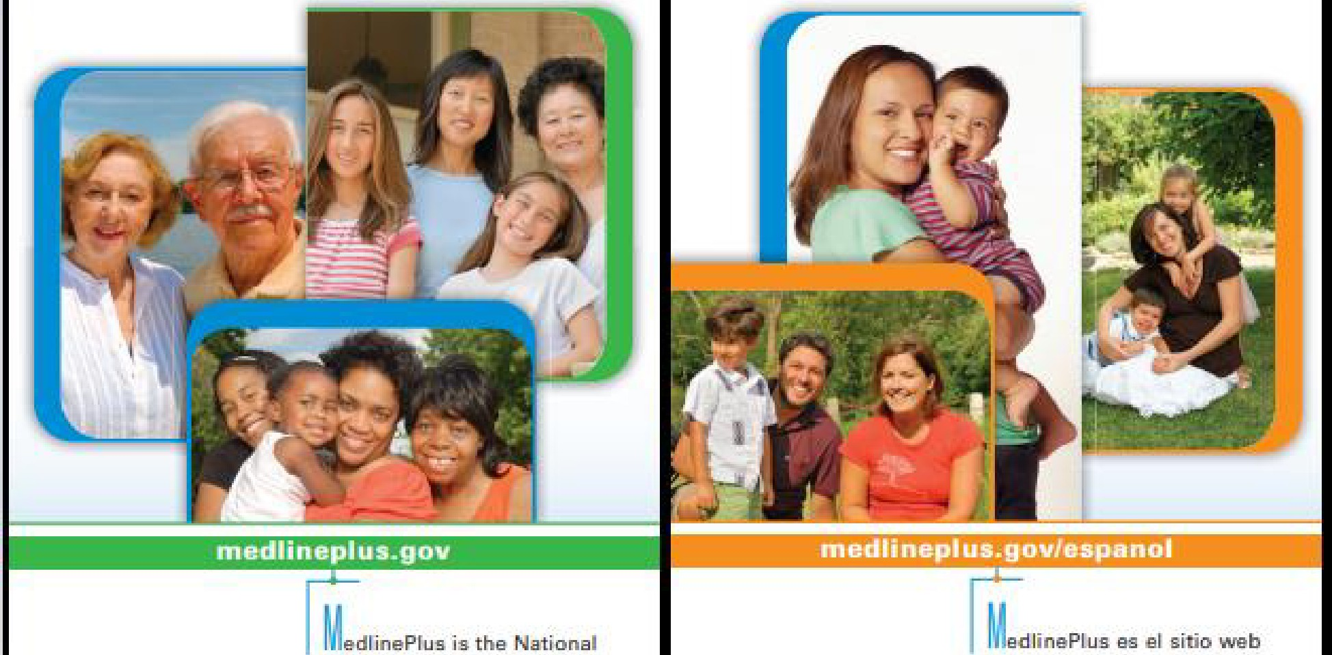
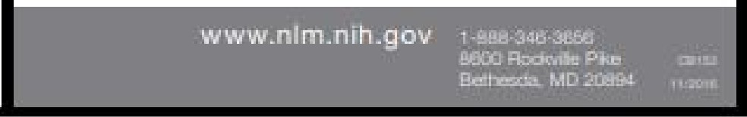
lm;elilutes of Heslth's Web sits for patients ani:I their familias ani:lfriends. produced by the ationa:l !..ibrary of Medicine.

Hsaithlo ics
Information on coni:litioni., i:l[ssases and sl.a,yinEJ well, latest heaJth news, dictionsry definitions and encydop,edia articles with pictures

Drug + Sop lemsnls
Prescn,nion ani:I over-the-counl.er mei:licine!i, and herbs.
ideos +lo□.ls
Videos on ana!omv. surgical prooedure.s and heal1h'f livi1111, EJB m,sa, ca[cula1ora and quizz.es kl check your health antl test yo'ur·klllowledge

e□linePlusC□naecl
Un'.kg electronic health record!! and patienl
portals to MedlinePlus information al::mul specific diagno.s,aa, medicatrons. and lab tests
de fos lnst[tutos acionalas de Salmi para padentas, sus familias y aimigos:. prnducida por la Elibliotec-a Nac'ional i:le Mei:licina.

Tsmas□eSalud
rnformacion so bra condkionas, enferrnei:lades
v bis nestar, ultimas noticias de aaI ud y une
en1:iclo p,adia con ilui.traGionas
Dr□Da +SuplBmentos
Medic-amentos co rt y i;:in receta macl'ica, hiart:Ja<s v auplamentos
Vi□e□ +Multlme□ia
Vic:lao.si;;obra anatornie, prooedirn[entos quirurgicoa y bianastar, juagos. calculac:lora y prnabae
para chequear au seluc:I y poner a pruebe sus conocimiemoa

edlinePlus[□noe l
Conecta historias c:Unicas elactronic:as y porteJes para el pacienle a infm-maciiln sabre dfegnasticos y e amenes de laboretoria eapecificos en Mec:mnaPlus
...4- 1111) ll.S. National Library of Medicloe
- ::--i

