Field Guide to Play
Cultivate a playful library culture

December 7, 2023

Facilitated by Kieran Hixon, Christine Kreger, & Sharon Morris

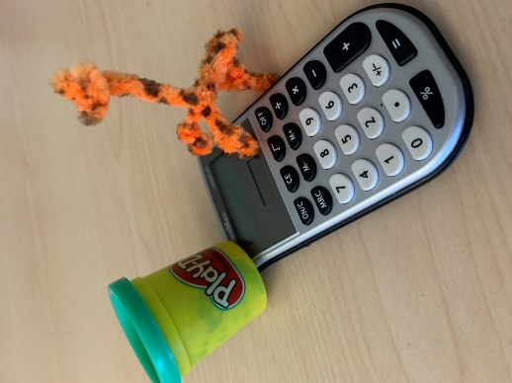 | Workshop Objectives  Greater understanding of play & the benefits of play at work.  Clarity on your play personality.  Plan for adding more play into your work.

Made possible through the Institute of Museum and Library Services (IMLS) administered by the Colorado State Library.

Introduction

Agenda

- Introduction  - Defining Play  - Benefits of Play  - Your Play Style  - Play at Work  - Play with Others | 

Defining Play

Your Early Experiences with Play
____________________________________________________________________________________________________________________________________________________________________________________________________________________________________________________________________________________________________________________________________________________________________________________________________________________________________________________________________________________________________________________________________________________________________________________

Research terms used to define play

Purposeless Intrinsically motivated All-consuming Nonliteral (involves pretense) Active (not passive)
Fun Self-directed Engaging Self-chosen Imaginative
Requires attention Non-stressed frame of mind Freeing (unimpeded movement) Arouses friendly feelings
Increases joy Absent of serious, practical, or harmful intent Spontaneous activity Aimless
Whimsical For enjoyment and recreation
____________________________________________________________________________________________________________________________________________________________________________________________________________________________________________________________________________________________________________________________________________________________________________________________________________________________________________________________________________________________________________________________________________________________________________________

Your definition of play

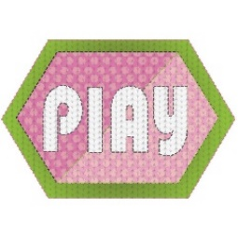
“The opposite of play is not work, it’s depression.”
― Brian Sutton-Smith

Benefits of Play at Work – (Brown)

- Better work relationships
- Increases productivity
- Reduction in stress
- Skill development
- More creative
- Increases intelligence
- More adaptable

Your notes on benefits
____________________________________________________________________________________________________________________________________________________________________________________________________________________________________________________________________________________________________________________________________________________________________________________________________________________________________________________________________________________________________________________________________________________________________________________



“Play is the highest form of research.”
― Albert Einstein

Play Types & Your Play Personality

Which Play Types Most Resonate for You?
Joker  Jokes, humorous remarks, puns, hilarious stories, nonsense, practical jokes | Kinesthete  Movement, dance, active sports (not to win), yoga, physical play | Explorer  Venture to the unknown, new things or ideas, visit new places
Competitor  Being your best, like specific rules and clear winners, keeping score | Director  Natural organizer, fun in planning and executing events, being in control, work magic | Collector  Collect the most, rarest, best, of things that interest you, things or places
Creator/Artist  Making something out of nothing, doodling, process rather than results, make or fix things | Storyteller  Imaginative, creating stories to tell or show, make things interesting through story | Other?

Combine Play Types to Define your Unique Play Personality
____________________________________________________________________________________________________________________________________________________________________________________________________________________________________________________________________________________________________________________________________________________________________________________________________________________________________________________________________________________________________________________________________________________________________________________


Play Space
“Individually, we are one drop. Together, we are an ocean.”
― Ryunosuke Satoro

Play at Work

Play on a busy day
____________________________________________________________________________________________________________________________________________________________________________________________________________________________________________________________________________________________________________________________________________________________________________________________________________________________________________________________________________________________________________________________________________________________________________________
Play after a dip in energy
____________________________________________________________________________________________________________________________________________________________________________________________________________________________________________________________________________________________________________________________________________________________________________________________________________________________________________________________________________________________________________________________________________________________________________________
Play when it’s stressful
____________________________________________________________________________________________________________________________________________________________________________________________________________________________________________________________________________________________________________________________________________________________________________________________________________________________________________________________________________________________________________________________________________________________________________________

Benefits You Want  - Better work relationships  - Increased productivity  - Reduction in stress  - Skill development  - More creative  - Increased intelligence  - More adaptable | Your Play Style  Your Ideas for Play (& others)



Play with Others – Team Play

Benefits You Want  - Better work relationships  - Increased productivity  - Reduction in stress  - Skill development  - More creative  - Increased intelligence  - More adaptable | Your Play Style as Part of a Team  Your Ideas for Play for Teamwork

Library Culture
- What area will benefit from more play?

- How will you experiment with play in public services?

- How will you share play with your team?
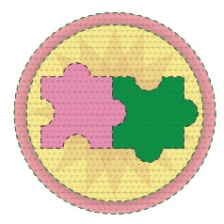
“Almost every attribute of your potential – from intelligence to creativity to leadership to personality and engagement --- is interconnected with others.”
― Shawn Achor

References & Resources

BOOKS
- Achor, S. (2018). Big potential: How transforming the pursuit of success raises our achievement, happiness, and well-being. New York, NY: Currency
- Brown, S., Vaughn, C. (2009) Play: How it shapes the brain, opens the imagination, and invigorates the soul, New York: Avery.
- Heath, C. & Heath, D. (2017). The power of moments: Why certain experiences have extraordinary impact. New York, NY: Simon and Schuster.

ONLINE
- American Journal of Play https://www.journalofplay.org/
- Brown, S. (2015) “How does play shape our development?” TED Radio Hour
https://www.npr.org/2015/03/27/395065944/how-does-play-shape-our-development
- Brown, S. (2014) “Play doesn’t end with childhood: Why adults need recess too.” All Things Considered https://www.npr.org/blogs/ed/2014/08/06/336360521/play-doesnt-end-with-childhood-why-adults-need-recess-too
- National Institute for Play https://www.playcore.com/drstuartbrown
- Plays-In-Business https://www.plays-in-business.com/
- Schutte, Kate. (April 21, 2012). Minute improv yes and. https://www.youtube.com/watch?v=MHnMRTnXOwk

“Get behind other people’s success. Your life was built on other people’s dreams, so let’s not let them down.”
― Dionica Nava

