
Trends &

How Libraries Respond

February 8, 2023
Colorado State Library | Kieran Hixon & Sharon Morris


Learning Objectives
- Identify trends that impact libraries
- Analyze trends through the lens of library operations, services, and value
- Gain new resources to explore trends into the future

Agenda

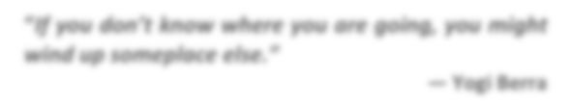
Trends with 3 points of view Growth Mindset Guest Experience
“If you don’t know where you are going, you might wind up someplace else.”
Yogi Berra
Your Turn
Artificial Intelligence Climate Change
Inclusion, Diversity, Equity, Access Politics
Summary & Evaluation

Key points
- Notice a trend.
- Understand how another industry is moving forward with the trend (to understand the potential of the trend).
- Think of the trend with 3 library lenses
  - Behind the Scenes: How do we use it to improve our work?
  - On the Stage: How do we empower others in our community with this trend?
  - On the Marquee: How can we leverage the trend to increase?

Notes


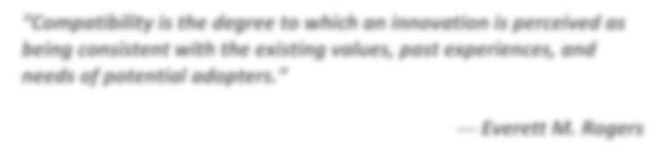
“Compatibility is the degree to which an innovation is perceived as being consistent with the existing values, past experiences, and needs of potential adopters.”
Everett M. Rogers






Mindsets
- Effort is an important part of learning.
- With effort, you focus on learning the process.
- You’d rather improve than worry about looking good.

- Embrace challenge as an opportunity to grow & learn
- Persevere, focusing on process rather than achieving success.
- Mistakes are learning opportunities and ways to improve.
- Focus on mistake recovery
Challenges
Effort
- Get discouraged by mistakes.
- Focus on avoiding mistakes.
- Get defensive, take feedback personally.
- Ignore or reject useful criticism or feedback.
- Appreciate constructive feedback.
- Welcome learning from criticism.
Feedback
Mistakes
Fixed Mindset Growth Mindset





- Skills, intelligence, and talents are fixed at birth.
- Errors are shameful and should be avoided.
- Some people are just always going to be better while others are not.
- We have not control of your abilities.
Beliefs

- You have the capacity to learn and grow your skills and talents.
- Errors help us to be curious and to learn new things.
- People are good at something because they built their ability.
- We are in control of our abilities.
- Effort is negative, not useful.
- Effort shows you aren’t good at something. It makes you look bad.
- Back down and avoid challenges.
- Quit when something is hard.




- Potential is best met individually.
- Potential is fixed. You only have a certain amount that you either get to or don’t.
- Those who don’t live up to their potential are failures.
Potential
- Potential is expanded by collaborating with others.
- Potential is limitless & grows with effort, competence, and mastery.
- Life is filled with ways to grow potential in a myriad of arenas.
*Chart based on Accredited Online Training. (May 15, 2018); Dweck, C. (2007). Growth mindset: The new psychology of success. New York, NY: Ballantine Books, and Achor, S. (2018). Big Potential: How transforming the pursuit of success raises our achievement, happiness, and well-being. New York, NY: Currency

Mindsets in Libraries

Behind the Scenes: Internal Library Functions

On the Stage: Library Services

On the Marquee: Community’s Perceived Value of the Library



“We are trendsetters and not trend sweaters.”
Takeoff

Guest Experience

- Ease of Access & Use
- Many options & personal choice
- Unexpected Delight
- Connecting with others
- Meaningful moments
- Encouragement of repeat use
“The trend is your friend.”
Martin Zweig
Behind the Scenes: Internal Library Functions

On the Stage: Library Services

On the Marquee: Community’s Perceived Value of the Library


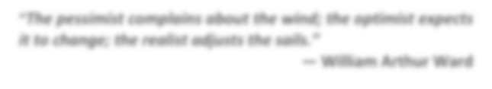
Artificial Intelligence
The pessimist complains about the wind; the optimist expects it to change; the realist adjusts the sails.”
William Arthur Ward
Artificial Intelligence or AI has rapidly emerged as a powerful new technology. Its ability to perform tasks requiring human intelligence has led to its widespread adoption, with 86% of companies considering it mainstream technology as of 2021. Like many technological advances, it is received with reactions ranging from captivation to fear. On the one hand, AI promises rapid economic growth and wide-ranging improvements from catching financial fraud to more accurate health diagnostic systems. On the other hand, it raises ethical concerns in social injustice, privacy and data, and threats to security. The impact of AI on our lives, communities, and the future of work is a subject of intense debate.
- What should we embrace and what should we be leery of?
- How could AI reshape our society?
This conversation is an invitation to explore our values, how AI could impact your work, library service, and changes in your community.
Artificial Intelligence: the development and implementation of computer systems capable of performing tasks that typically require human intelligence - learning, reasoning, problem-solving and decision-making.
Source. (https://livingroomconversations.org/wp-content/uploads/2023/07/Artificial-Intelligence.pdf)
Behind the Scenes: Internal Library Functions

On the Stage: Library Services

On the Marquee: Community’s Perceived Value of the Library

Climate Change
Climate change refers to long-term shifts in temperatures and weather patterns. In our time, these shifts manifest in the greater frequency of hurricanes, earthquakes, tornadoes, flooding, blizzards, droughts, and wildfires. Other factors, such as the rise of microplastics, or the destruction of pollinators due to pollution and insecticides, threaten human health and food supplies.
Climate change is also accelerated by the use of fossil fuels and methane emissions. Energy, industry, transport, buildings, agriculture, and land use are among the main sectors causing greenhouse gases.
Source. (https://www.un.org/en/climatechange/what-is-climate-change)

Behind the Scenes: Internal Library Functions

On the Stage: Library Services

On the Marquee: Community’s Perceived Value of the Library



“If you don’t know where you are going, any road will get you there.”
Lewis Carroll

Equity, Diversity, Inclusion & Access
Equity, diversity, and inclusion (EDI) is a conceptual framework that promotes the fair treatment and full participation of all people, especially populations that have historically been underrepresented or subject to discrimination because of their background, identity, disability, etc.
Source <https://www.apa.org/topics/equity-diversity-inclusion>.

These populations, and library resources concerning them, continue to face discrimination, particularly including people of color and members of the LGBTQ+ population. EDI also embraces other demographic shifts: the graying of America, the divide between rural and urban, and inequities of income and education. In addition, people with disabilities, deaf people, blind people, and persons with neurodivergent or developmental issues often experience access issues that can be resolved beyond legal requirements (Americans with Disabilities Act <https://www.ada.gov/>) with efforts of Universal Design <https://universaldesign.ie/what-is-universal-design/>.

Behind the Scenes: Internal Library Functions

On the Stage: Library Services

On the Marquee: Community’s Perceived Value of the Library

Politics
Politics is shorthand for the interaction between various competing interests to set policy direction and law. In society today, it shows up most prevalently as community polarization.
Additionally, in recent state and national legislative session, libraries are impacted by increased legislation that affect library operations, services, and budgets (ADA regulations, compensation for sexual abuse, new Human Resources requirements, non-gender bathrooms in new buildings and remodels, and property tax adjustments, to name a few).

The political landscape in the United States also includes the current surge of intellectual freedom challenges to library resources, displays, and meeting rooms.

Behind the Scenes: Internal Library Functions

On the Stage: Library Services

On the Marquee: Community’s Perceived Value of the Library

References & Resources
BOOKS
- Achor, S. (2018). Big potential: How transforming the pursuit of success raises our achievement, happiness, and well-being. New York, NY: Currency

- Dweck, C. (2007). Growth mindset: The new psychology of success. New York, NY: Ballanstine Books

- Heath, C. & Heath, D. (2017). The power of moments: Why certain experiences have extraordinary impact. New York, NY: Simon and Schuster.

ONLINE TRENDS RESOURCES
  - American Library Association, Center for the Future of Libraries https://www.ala.org/tools/sites/ala.org.tools/files/content/LibraryoftheFuture/Tren dCards/ALACenterfortheFutureofLibraries_TrendCards1_Duplex.pdf

  - Colorado Association of Libraries, Futurist Interest Group https://calfig.org/
  - Living Room Conversations: https://livingroomconversations.org/

  - Pew Research Foundation https://www.pewresearch.org/

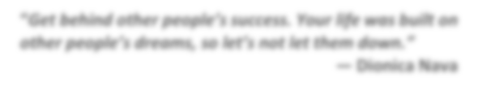
“Get behind other people’s success. Your life was built on other people’s dreams, so let’s not let them down.”
Dionica Nava

10 | P a g e

