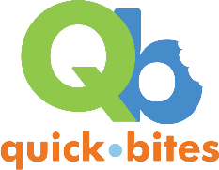
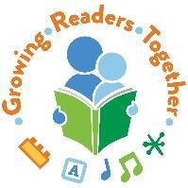
Early Literacy Tips that Stick:
Refining Your Early Literacy Message
with Melody Garcia: GRT Early Literacy Specialist
garcia_m@cde.state.co.us

Resources for Early Literacy Messages

Helpful Websites:

Colorado Libraries for Early Literacy (CLEL): Early literacy tips, blogs, CLEL Bells Book Awards lists and activitites
https://www.clel.org

Early Lit with Saroj Ghoting: ECRR resources, research, trainings and storytime shares http://www.earlylit.net

Mel’s Desk: Storytime and early literacy resources http://melissa.depperfamily.net/blog/

Zero to Three: Child development research for parents and teachers https://www.zerotothree.org

National Association for the Education of Young Children (NAEYC): Tips and articles on child development, reading & writing
https://www.naeyc.org

Reading Rockets: Research, resources, and partent literacy tips https://www.readingrockets.org

Colorin Colorado: Resources and early literacy tips for bilingual/ Spanish storytime https://www.colorincolorado.org

Book:
Supercharged Storytimes: An Early Literacy Planning and Assessment Guide (2016) by J. Elizabeth Mills, Kathleen Campana, and Saroj Nadkarni Ghoting

My Favorite Literacy Messages: “Grown-ups, when we Our children are learning
And that prepares them to be good readers because . . .”

When we run our fingers under big, bold words as we read, our children are learning that words have meaning, we’re not just making up a story from the pictures. And this prepares them to be good readers because they are looking for words even before they learn to decode them.

When we sing songs like the Itsy Bitsy Spider, that tell a short story, our children are learning that stories have a beginning, middle, and end. That prepares them to be good readers because they understand sequencing in stories and are more able to understand what they read.

When we play with small percussion instruments such as bells, rhythm sticks, shakers, and drums our children are gaining muscular development and coordination. In fact, research has shown that children who play with music have greater success in reading, writing, and spelling.

When we ask our children questions and give them enough time to answer, our children are building important brain connections. Research has shown that it takes 5 to 7 seconds for a young child to process the question and respond to you.
When we trace letters in the air our children are learning to recognize letters by using their whole bodies. And that prepares them to be good readers because young children learn kinetically and when we engage their bodies they make strong brain connections.
Picture books have more rare words than daily conversation, so when we read new words and take the time to explain them, our children are filling up their "word bucket” and that prepares them to be good readers because it is easier to read a word you are already familiar with,

When we play Peek-a-Boo with our babies, they are making important brain connections. That prepares them to be good readers because research has should that children learn best when they feel safe, happy and loved
When we play with bubbles, it’s not only fun, our children are practicing hand-eye coordination and fine motor skills. That prepares them to be good readers and writers because those same skills are used to track words on a page and hold a pencil.

When we bounce our babies as we recite nursery rhymes, they are feeling the natural rhythm of language, and that helps them develop language and conversation skills.

