Draft a Collection Management Plan!

Jot some of your initial ideas down here. Some components to consider include:
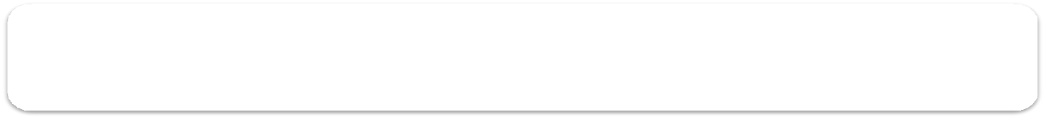
What is your current state? (Where are you starting from in your collection management journey?)

What is working well?

What needs to be improved?

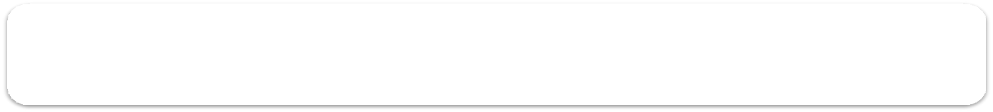
What are your goals? (These could include increasing turnover, decreasing dusty items on the shelves, increasing circulating, etc.)

1.

2.

3.

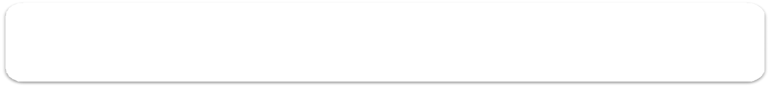

Who will be involved? (All library staff? Select team?)

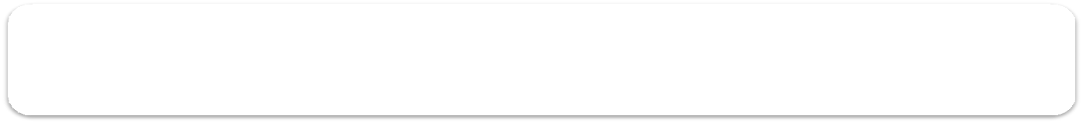

Training (Who needs to be trained, by whom, and how?)

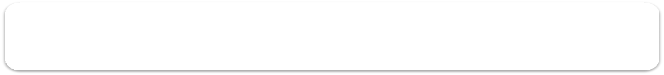

Communication (What will your communication strategy be?)
What is working well?

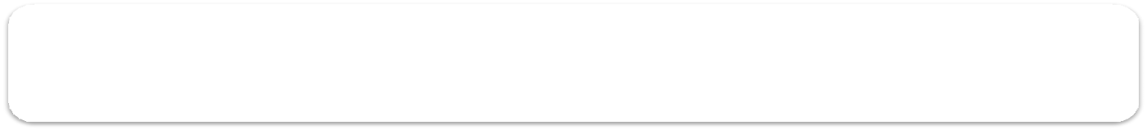
Who needs to approve your collection management plan? (Your boss? Your board?)

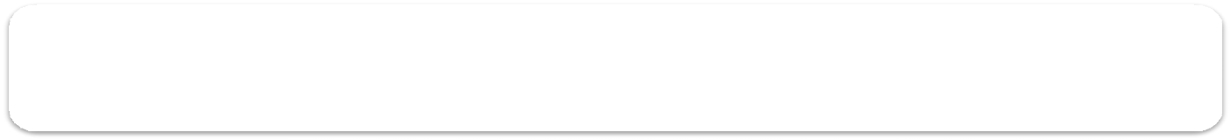
How will you organize your Collection Management Plan?
(Schedule/calendars/other tools)

