Handouts for Xbee class
Xbee Series 1 address_________________________
Xbee Series 1 address_________________________
Xbee Series 2 coordinator address ______________________
Xbee Series 2 router address___________________________
Chat Pan ID___________________
Doorbell Pan ID________________
Color Project Pan ID_____________
AT Commands
- AT Should return OK
- ATID Set/Read Pan ID
- ATSH Read high bits of 64-bit address
- ATSL Read low bits of 64-bit address
- ATDH Set/Read high bits of the destination address
- ATDL Set/Read low bits of the destination address
- ATCN Command Null – Exit command mode
- ATWR Write your changes to the chip
- ATMY Set (Series 1 only)/Read 16-bit address
- ATD# 0-7 Set/Read I/O pins
- ATP# 0-1 Set/Read PWM pins
- 0 Disable
- 1 Built-in Function
- 2 Analog Input
- 3 Digital Input
- 4 Digital output (default low)
- 5 Digital output (default high)
- ATIR I/O Rate – how often the pins are read, set in milliseconds
- ATIT Iteration Tailor – number of samples taken before sending (Series 1)
- ATIA Input Address – Allows output pins to be remotely controlled (Series 1)
- ATRE Reset the module
- ATNI Node Identifier – Allows you to 'name' your Xbees
- ATND Node Discover - Returns a bunch of information
- ATBD Set baud rate (0-7)
- 3 9600
- 5 38400
- 7 115200
- ATAP API Enable (0 Disable, 1 Enable)
- ATJV Channel Verification (0 Disable, 1 Enable)

Project 1 – Series 1 Chat

In this project you will pick a partner (the person next to you works, but it doesn't have to be). You will each configure 1 Xbee to talk to your partners Xbee and only your partners. When you are done you should be able to open a terminal window, and talk to your partner over the Xbees.
Components:
- Xbee Series 1 x1
- Xbee Explorer
Partner 1:
- Insert Xbee into Xbee Explorer, plug Xbee explorer into your computer.
- Open a terminal window and connect at 9600 8-N-1 to your Xbee explorer
- Get into command mode (+++ with no enter)
- Set the Pan ID to the ID listed above, set the 16-bit address, and the destination address
- ATID ####
- ATMY 1
- ATDH 0
- ATDL 2
- Wait for the Xbee to time out or type ATCN
- Wait for your partner to be done
- Type in your terminal window and watch it show up in your partners window
Partner 2:
- Insert Xbee into Xbee Explorer, plug Xbee explorer into your computer.
- Open a terminal window and connect at 9600 8-N-1 to your Xbee explorer
- Get into command mode (+++ with no enter)
- Set the Pan ID to the ID listed above, set the 16-bit address, and the destination address
- ATID ####
- ATMY 2
- ATDH 0
- ATDL 1
- Wait for the Xbee to time out or type ATCN
- Wait for your partner to be done
- Type in your terminal window and watch it show up in your partners window

Project 2 – Series 1 Doorbell
In this project you will be building 2 circuits. The first will have a button and an Xbee and the other will have an LED and an Xbee. Press the button and the LED lights up.
Components:
- Xbee Series 1 x2
- Button
- LED
- Breadboard x2
- Xbee breakout board x2
- Power Supply x2 (battery pack and 3.3V out from Arduino)
XBee 1:
- Insert Xbee into Xbee Explorer, plug Xbee explorer into your computer.
- Open a terminal window and connect at 9600 8-N-1 to your Xbee explorer
- Get into command mode (+++ with no enter)
- Set the Pan ID to the ID listed above, set the 16-bit address, the destination address, sample rate, samples to send, and set the pin to input
- ATRE
- ATID ####
- ATMY 1
- ATDH 0
- ATDL 2
- ATIR 64
- ATIT 1
- ATD0 3
- ATIA FFFF
- ATWR
- Grab one breadboard, 1 power supply, and a button and build the circuit in the schematic below. You will need to take the Xbee out of the Xbee Explorer to do this.
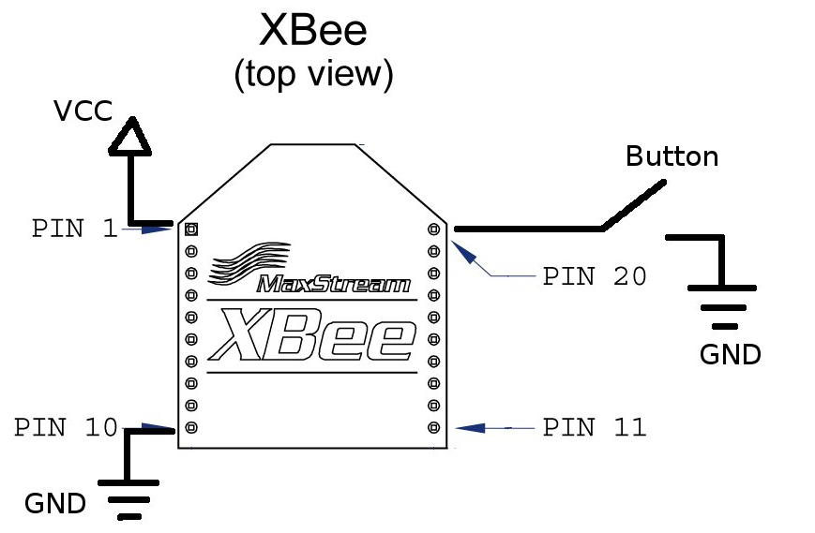
XBee 2:
- Insert Xbee into Xbee Explorer, plug Xbee explorer into your computer.
- Open a terminal window and connect at 9600 8-N-1 to your Xbee explorer
- Get into command mode (+++ with no enter)
- Set the Pan ID to the ID listed above, set the 16-bit address, the destination address, sample rate, samples to send, and set the pin to input
- ATRE
- ATID ####
- ATMY 2
- ATDH 0
- ATDL 1
- ATIR 64
- ATIT 1
- ATD0 5
- ATIA FFFF
- ATWR
- Grab one breadboard, 1 power supply, the LED and build the circuit in the schematics below. You will need to take the Xbee out of the Xbee Explorer to do this.

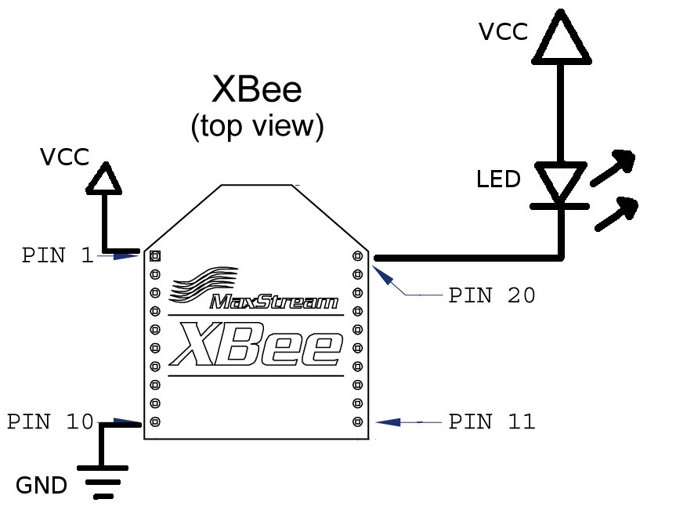

- Now press the button and watch the LED light up.

Project 3 – Series 2 Chat

In this project you will pick a partner (the person next to you works, but it doesn't have to be). You will each configure 1 Xbee to talk to your partners Xbee and only your partners. When you are done you should be able to open a terminal window, and talk to your partner over the Xbees.

Components:
- Xbee Series 2 x1
- Xbee Explorer

Partner 1:
- Insert Xbee into Xbee Explorer, plug Xbee explorer into your computer.
- Open X-CTU and write the Coordinator AT firmware.
- Open a terminal window and connect at 9600 8-N-1 to your Xbee explorer
- Get into command mode (+++ with no enter)
- Set the Pan ID to the ID listed above, and the destination address
- ATID ####
- ATDH 0013A200
- ATDL ######## (get this from your partner)
- Wait for the Xbee to time out or type ATCN
- Wait for your partner to be done
- Type in your terminal window and watch it show up in your partners window

Partner 2:
- Insert Xbee into Xbee Explorer, plug Xbee explorer into your computer.
- Open X-CTU and write the Router AT firmware.
- Open a terminal window and connect at 9600 8-N-1 to your Xbee explorer
- Get into command mode (+++ with no enter)
- Set the Pan ID to the ID listed above, and the destination address
- ATID ####
- ATDH 0013A200
- ATDL ######## (get this from your partner)
- Wait for the Xbee to time out or type ATCN
- Wait for your partner to be done
- Type in your terminal window and watch it show up in your partners window

Project 4 – Series 2 Light Sensor
Wondering if you have the right lighting for a romantic dinner? Then this project is for you. If you don't remember the last time you had a romantic dinner, well, then it’s still a fun project. A light sensor to read the light, an Arduino to figure out if it’s in the “ideal range” and a remote circuit to light an LED to tell you everything is good (or not good). While you are doing this project bear in mind that one of your Xbees will be programmed using the API firmware and the other will be programmed using the AT firmware. The main difference between the modes is that the API mode sends more complete packets of information allowing for sum checking of data, while the AT mode does not.
Components:
- Xbee Series 2 x2
- Light Sensor
- 20K resistor
- LED
- Breadboard x2
- Xbee Breakout Board x2
- Power Supply x2 (battery pack and 3.3V out from Arduino)
XBee 1:
- Insert Xbee into Xbee Explorer, plug Xbee explorer into your computer.
- Open X-CTU and write the Router AT firmware.
- Open a terminal window and connect at 9600 8-N-1 to your Xbee explorer
- Get into command mode (+++ with no enter)
- Set the Pan ID to the ID listed above, the destination address, and other fun stuff
- ATRE
- ATID ####
- ATDH ####
- ATDL ####
- ATJV1
- ATD0 2
- ATIR64
- ATWR
- Grab one breadboard, 1 power supply, the resistor, and photosensor and build the circuit in the schematics below.
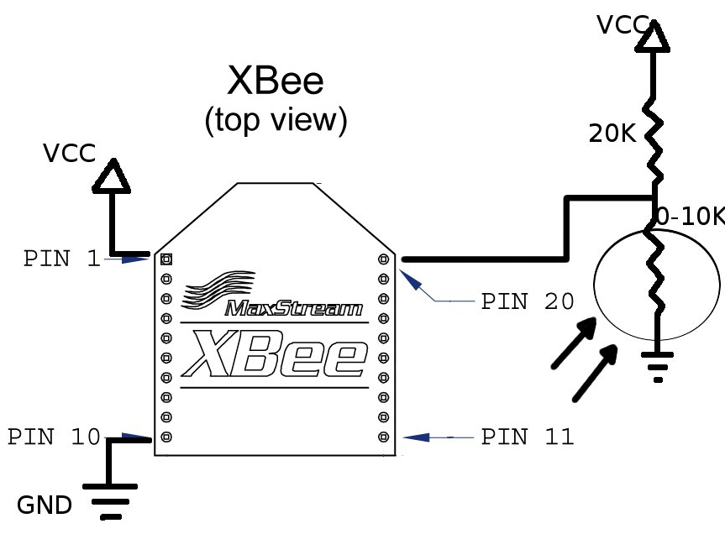
XBee 2:
- Insert Xbee into Xbee Explorer, plug Xbee explorer into your computer.
- Open X-CTU and write the Coordinator API firmware.
- Click the Enable API box
- You will now have to make all changes in X-CTU
- Set the following parameters
- PAN ID (ID)
- Destination High (DH)
- Destination Low (DL)
- Write the parameters to the chip
- Open Arduino IDE 022
- Plug in your Arduino
- Select the correct board and serial port
- Upload the code below to your Arduino (code is also available at http://www.faludi.com/bwsn_book/code/Romantic_Lighting_Sensor/Romantic_Lighting_Sensor.pde)
- Grab one breadboard, 1 breakout board, 1 LED, and build the circuit in the schematics below.
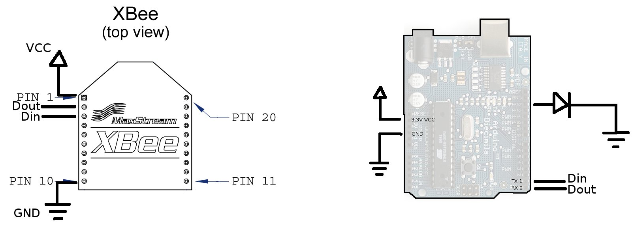

//Arduino Code for Light Sensor Circuit
//Note: You will not be able to program your Arduino with the Xbee //plugged in due to the fact that they share Rx and Tx pins!

#define VERSION "1.02"
int LED = 11;
int debugLED = 13;
int analogValue = 0;

void setup() {
pinMode(LED,OUTPUT);
pinMode(debugLED,OUTPUT);
Serial.begin(9600); }

void loop() {
// make sure everything we need is in the buffer
if (Serial.available() >= 21) {
// look for the start byte
if (Serial.read() == 0x7E) {
//blink debug LED to indicate when data is received
digitalWrite(debugLED, HIGH);
delay(10);
digitalWrite(debugLED, LOW);
// read the variables that we're not using out of the buffer
for (int i = 0; i<18; i++) {
byte discard = Serial.read();
}
int analogHigh = Serial.read();
int analogLow = Serial.read();
analogValue = analogLow + (analogHigh * 256);
}
}
/*
* The values in this section will probably
* need to be adjusted according to your
* photoresistor, ambient lighting and tastes.
* For example, if you find that the darkness
* threshold is too dim, change the 350 value
* to a larger number.
*/
// darkness is too creepy for romance
if (analogValue > 0 && analogValue <= 350) {
digitalWrite(LED, LOW);
}
// medium light is the perfect mood for romance
if (analogValue > 350 && analogValue <= 750) {
digitalWrite(LED, HIGH);
}
// bright light kills the romantic mood
if (analogValue > 750 && analogValue <= 1023) {
digitalWrite(LED, LOW);
}
}

Project 5 – Series 2 Color Project
In this project everyone gets to build a sensor that sends 3 values from 3 potentiometers to the coordinator Xbee. In this case the coordinator Xbee is at the front of the classroom attached to a computer running a processing script. Turn the potentiometers to adjust red, green, and blue and see if you can match the colors.
Components:
- Xbee Series 2
- Potentiometer x3
- Breadboard
- Xbee Breakout Board
XBee 1:
- Insert Xbee into Xbee Explorer, plug Xbee explorer into your computer.
- Open X-CTU and write the Router AT firmware.
- Open a terminal window and connect at 9600 8-N-1 to your Xbee explorer
- Get into command mode (+++ with no enter)
- Set the Pan ID to the ID listed above, the destination address, and other fun stuff
- ATRE
- ATID ####
- ATDH
- ATDL
- ATJV 1
- ATD02, ATD12, ATD22
- ATIR3E8
- ATWR
- Grab one breadboard, 1 breakout board, 3 potentiometers and build the circuit according the he schematic below.
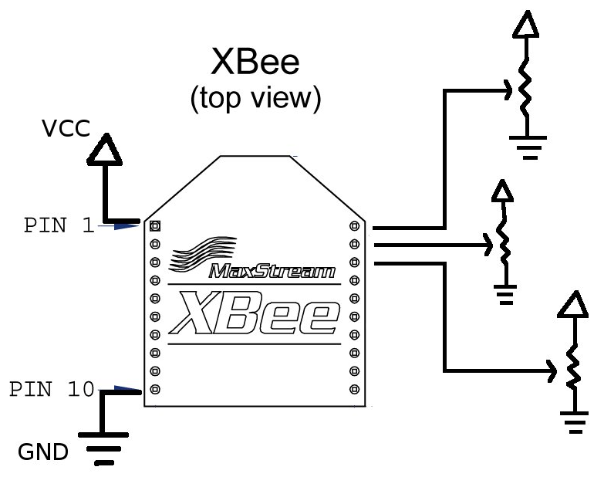

Xbee 2 (you do not need to do this, but here is the information if you want to do this at home):
- Insert Xbee into Xbee Explorer, plug Xbee explorer into your computer.
- Open X-CTU and write the Coordinator API firmware.
- Click the Enable API box
- You will now have to make all changes in X-CTU
- Set the following parameters
- PAN ID (ID)
- Destination High (DH)
- Destination Low (DL)
- Write the parameters to the chip
- Open Processing and run the program below

/*
* Matching color game from sets of Analog sensors
* by Ben Leduc-Mills
* based off code by Rob Faludi http://faludi.com
*/
// used for communication via xbee api
import processing.serial.*;
// xbee api libraries available at http://code.google.com/p/xbee-api/
// Download the zip file, extract it, and copy the xbee-api jar file
// and the log4j.jar file (located in the lib folder) inside a "code"
// folder under this Processing sketch’s folder (save this sketch, then
// click the Sketch menu and choose Show Sketch Folder).
import com.rapplogic.xbee.api.ApiId;
import com.rapplogic.xbee.api.PacketListener;
import com.rapplogic.xbee.api.XBee;
import com.rapplogic.xbee.api.XBeeResponse;
import com.rapplogic.xbee.api.zigbee.ZNetRxIoSampleResponse;
String version = "1.1";
// *** REPLACE WITH THE SERIAL PORT (COM PORT) FOR YOUR LOCAL XBEE ***
String mySerialPort = "/dev/tty.usbserial-A40084zG";
// create and initialize a new xbee object
XBee xbee = new XBee();
int error=0;
// make an array list of thermometer objects for display
ArrayList colorBoxes = new ArrayList();
// create a font for display
PFont font;
int R, G, B;
float value1, value2, value3; //values from the 3 sensors
int tolerance = 20; //how close do we need to get
void setup() {
size(850, 850); // screen size
smooth(); // anti-aliasing for graphic display
//set up target colors
R = round(random(0, 255));
G = round(random(0, 255));
B = round(random(0, 255));
// You’ll need to generate a font before you can run this sketch.
// Click the Tools menu and choose Create Font. Click Sans Serif,
// choose a size of 10, and click OK.
font = loadFont("SansSerif-10.vlw");
textFont(font); // use the font for text
// The log4j.properties file is required by the xbee api library, and
// needs to be in your data folder. You can find this file in the xbee
// api library you downloaded earlier
PropertyConfigurator.configure(dataPath("")+"log4j.properties");
// Print a list in case the selected one doesn't work out
println("Available serial ports:");
println(Serial.list());
try {
// opens your serial port defined above, at 9600 baud
xbee.open(mySerialPort, 9600);
}
catch (XBeeException e) {
println("** Error opening XBee port: " + e + " **");
println("Is your XBee plugged in to your computer?");
println("Did you set your COM port in the code near line 20?");
error=1;
}
}
// draw loop executes continuously
void draw() {
background(224); // draw a light gray background
fill(R, G, B); //set the fill to our randomly generated color
rect(width/2-125, 10, 250, height-20); //and draw a nice big rect for people to
match
// report any serial port problems in the main window
if (error == 1) {
fill(0);
text("** Error opening XBee port: **\n"+
"Is your XBee plugged in to your computer?\n" +
"Did you set your COM port in the code near line 20?", width/3, height/2);
}
SensorData data = new SensorData(); // create a data object
data = getData(); // put data into the data object
//data = getSimulatedData(); // uncomment this to use random data for testing
// check that actual data came in:
if (data.value1 >=0 && data.address != null) {
int i;
boolean foundIt = false;
for (i = 0; i < colorBoxes.size(); i++) {
if ( ((ColorBox) colorBoxes.get(i)).address.equals(data.address) ) {
foundIt = true;
break;
}
}
value1 = data.value1;
value2 = data.value2;
value3 = data.value3;
//if the box exists already, update the color values
if (foundIt) {
((ColorBox) colorBoxes.get(i)).value1 = value1;
((ColorBox) colorBoxes.get(i)).value2 = value2;
((ColorBox) colorBoxes.get(i)).value3 = value3;
}
//if there's room in the array, create a new box
else if (colorBoxes.size() < 12) {
// ColorBox(address, sizeX, sizeY, posX, posY)
colorBoxes.add(new ColorBox(data.address, 260, 40, 20, (colorBoxes.size()) * 61
+ 10));
((ColorBox) colorBoxes.get(i)).value1 = value1;
((ColorBox) colorBoxes.get(i)).value2 = value2;
((ColorBox) colorBoxes.get(i)).value3 = value3;
}
//draw the color boxes
for (int j = 0; j<colorBoxes.size(); j++) {
((ColorBox) colorBoxes.get(j)).render();
}
//if the R, G and B of the box are close enough, declare a match!
if ((value1 < R + tolerance && value1 > R - tolerance) &&
(value2 < G + tolerance && value2 > G - tolerance) &&
(value3 < B + tolerance && value3 > B - tolerance)) {
println("Close? " + R + " " + value1 + " " + G + " " + value2 + " " + B + "
" + value3);
//text(((ColorBox) colorBoxes.get(i)).address + " WINS!!!", width/2-125,
height/2-125);
fill(200, 20, 20);
textSize(20);
text(" WINS!!!", ((ColorBox) colorBoxes.get(i)).posX,
((ColorBox) colorBoxes.get(i)).posY+20);
}
println("Close? " + R + " " + value1 + " " + G + " " + value2 + " " + B + " "
+ value3);
}
} //end of draw loop
// defines the data object
class SensorData {
float value1;
float value2;
float value3;
String address;
}
// used only if getSimulatedData is uncommented in draw loop
//
SensorData getSimulatedData() {
SensorData data = new SensorData();
int value = int(random(750, 890));
String address = "00:13:A2:00:12:34:AB:C" + str( round(random(0, 9)) );
//data.value = value;
data.address = address;
delay(200);
return data;
}
// queries the XBee for incoming I/O data frames
// and parses them into a data object
SensorData getData() {
SensorData data = new SensorData();
//int value = -1; // returns an impossible value if there's an error
float value1 = -1; //sensor values
float value2 = -1;
float value3 = -1;
String address = ""; // returns a null value if there's an error
try {
// we wait here until a packet is received.
XBeeResponse response = xbee.getResponse();
// uncomment next line for additional debugging information
//println("Received response " + response.toString());
// check that this frame is a valid I/O sample, then parse it as such
if (response.getApiId() == ApiId.ZNET_IO_SAMPLE_RESPONSE
&& !response.isError()) {
ZNetRxIoSampleResponse ioSample =
(ZNetRxIoSampleResponse)(XBeeResponse) response;
// get the sender's 64-bit address
int[] addressArray = ioSample.getRemoteAddress64().getAddress();
// parse the address int array into a formatted string
String[] hexAddress = new String[addressArray.length];
for (int i=0; i<addressArray.length;i++) {
// format each address byte with leading zeros:
hexAddress[i] = String.format("%02x", addressArray[i]);
}
// join the array together with colons for readability:
String senderAddress = join(hexAddress, ":");
//print("Sender address: " + senderAddress);
data.address = senderAddress;
// get the value of the first input pin
value1 = ioSample.getAnalog0();
//print(" analog value1: " + value1 );
value2 = ioSample.getAnalog1();
//print(" analog value2: " + value2 );
value3 = ioSample.getAnalog2();
//print(" analog value3: " + value3 );
data.value1 = value1;
data.value2 = value2;
data.value3 = value3;
}
else if (!response.isError()) {
println("Got error in data frame");
}
else {
println("Got non-i/o data frame");
}
}
catch (XBeeException e) {
println("Error receiving response: " + e);
}
return data; // sends the data back to the calling function
}
//Class for color boxes (takes R,G,B values from 3 different sensors)
class ColorBox {
int sizeX, sizeY, posX, posY;
float value1, value2, value3;
String address;
ColorBox(String _address, int _sizeX, int _sizeY, int _posX, int _posY) {
//initialize ColorBox object
address = _address;
sizeX = _sizeX;
sizeY = _sizeY;
posX = _posX;
posY = _posY;
}
void render() {
noStroke();
//fill(value1, value2);
fill(value1, value2, value3);
rect(posX, posY, sizeX, sizeY);
textAlign(LEFT);
fill(0);
textSize(10);
text(address, posX, posY + sizeY + 10);
}
}

