

Colorado Business Express
Help Document
Version 1.0
October 25, 2011

Confidential and proprietary information: property of Colorado interactive not to be copied or distributed under any circumstance.
TABLE OF CONTENTS

Overview 3
1. Overview 4
1.1. Who can use CBE? 4
1.1.1. Colorado Department of Labor and Employment (CDLE) Requirements 4
1.1.2. Colorado Department of Revenue (DOR) Requirements 4
1.2. What do you need to begin a registration through CBE? 5
1.2.1. CDLE Requirements 5
1.2.2. DOR Requirements 5
Application Pages 7
1. Splash Page 8
2. Secretary of State Registration Page 9
3. Business Search Page 11
4. Business Organization Information Page 12
5. Owners, Partners, and Corporate Officers Page 14
6. Employee Page 16
7. Bank Information Page 18
8. Payroll Information Page 20
9. Products and Services Page 21
10. Type of Products and Services Page 22
11. Products and Services Details Page 23
12. Seasonal Business Page 24
13. Sales Tax Frequency Page 25
14. Review Page 26
15. Signature and Disclaimer Page 27
16. File Now Page 28
17. Checkout Utility 30
17.1. Credit Card information 30
17.2. ECheck Information 30
17.3. Customer Payment Information 31
17.4. Verify Bank/Credit Card Billing Information 33
18. Confirmation Page 35
19. Example Exit Pages 36
20. Who to contact with questions 38

Overview

Overview
Colorado Business Express (CBE) is an online tool to guide businesses through the process of filing for a sales tax account, wage withholding account, and/or unemployment insurance account. The system will determine, based on a series of questions, what the business is qualified to file for.

All of the information included in the Overview section can be found by going to https://www.colorado.gov/ColoradoBusinessExpress and clicking on “Do I Qualify?”

Who can use CBE?
Businesses must be registered with the Secretary of State’s office to use CBE. The only business types that don’t need to be registered are Individual Sole Proprietor and General Partnership. If users need to register with the Secretary of State, they can visit http://www.sos.state.co.us/pubs/business/fileAForm.html.

Colorado Department of Labor and Employment (CDLE) Requirements
A business can register with CDLE if the following statements are true:
- The business has never been assigned a Colorado Unemployment Insurance (UI) Employer Account Number.
- The business has a Federal Employer Identification Number (FEIN).
  - To obtain an FEIN, please reference http://www.irs.gov/businesses/small/article/0,,id=98350,00.html
- The business has at least one employee in Colorado to whom wages are being paid.
- The business is new or has not previously had an employee in Colorado.
- The business is not the result of a change of ownership of an existing business.
- This business is not an agricultural employer, a household/domestic employer, a 501(c)(3) or other nonprofit employer, a government employer, or a religious organization.
- This business is not the result of a purchase of assets, stocks, and/or employees of a previously established business.

Colorado Department of Revenue (DOR) Requirements
A business can register with DOR if the following statements are true:
- The business cannot register for a new sales tax account or wage withholding account if they have an existing account already associated with that FEIN or SSN.
- Businesses with an existing wage withholding account wishing to add a sales tax account, or with a sales tax account wishing to add a wage withholding account, may use CBE to complete that registration.
- The business provides products or taxable services.
- The business has a Federal Employer Identification Number (FEIN). The only business type that does not need an FEIN is Individual Sole Proprietor.

What do you need to begin a registration through CBE?
What you need is dependent on the path the business goes through. There are different requirements for the Employee path vs. Sales Tax path.

Employee Path: The employee path takes a user through the required questions to apply for a wage withholding account and an unemployment insurance account.
Sales Tax Path: The sales tax path takes a user through the required questions to apply for a sales tax or retailer’s use license.

CDLE Requirements
Businesses need the following to apply for an unemployment insurance account or wage withholding account (wage withholding is with DOR):
- Business name and trade name, if any.
- Federal Employer Identification Number (FEIN). The system will provide a link for businesses to look up their FEIN in several places through the application.
- Names and contact information for all the owners, partners, and/or corporate officers of this business.
- All applicable addresses, including primary business location, mailing, payroll, banking, primary worksite location, and any other addresses pertinent to the business.
- Date you paid or will pay $1500 in gross wages in a single quarter OR the ending date (Saturday) of the 20th week in the calendar year that individuals were or will be employed in Colorado. Example: On March 1, 2011, a business hires one Colorado part-time employee who earns $450 per month. The employee works for some portion of each of the 20 weeks that follow. A date of 07/16/2011 is entered for this field. Because the employer did not reach $1500 in gross wages in a single quarter, the employer is assigned an estimated Qualifying Date of July 16, 2011, and becomes liable to pay unemployment insurance premiums at that time.
- Payroll information, including the first date the business paid wages.
- Bank information.

DOR Requirements
Businesses need the following to apply for a sales tax account:
- Business name and trade name, if any.
- Federal Employer Identification Number (FEIN) or SSN that you want to register your business under. All businesses are required to use an FEIN unless they are Individual Sole Proprietor.
- Names and contact information for all owners, partners, and/or corporate officers of this business.
- All applicable addresses, including primary business location and mailing address.
- First date of sales.

Application Pages

Splash Page
The Splash page is the first page users see when going to CBE. From this page, you can start your filing, check to see if you are qualified to use the system, download paper registration forms, and find links to various agency websites for more information.

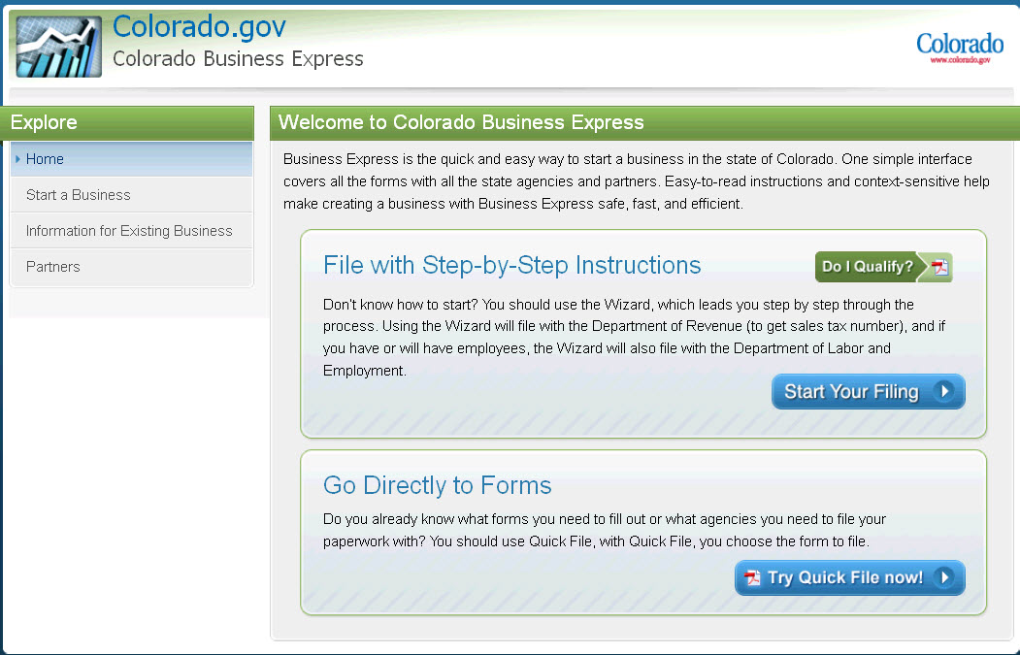

Below is a description of what the system will do when you click on various buttons/links:

Do I Qualify?: This link will open a document with a list of what a business needs to get started with CBE. It provides links to register with the Secretary of State office as well as a link to look up a business’ FEIN.
Start Your Filing: Clicking on Start Your Filing will take the user to the first page in CBE. This will begin the process of registering a business for a sales tax account, wage withholding account, and/or unemployment insurance account.
Try Quick File now!: This button links to downloadable versions of the CR-0100 and UITL-100 forms.
Start a Business: By clicking on Start a Business, the system will advance to a page with resource guides on how to start a business. For example, you can find the Custom Resource Guide which will allow you to customize what information you are looking for. This section of CBE will guide users to the correct website for the answers.
Information for Existing Businesses: The system will present a series of forms or Q&A for existing businesses.
Partners: The partners link will advance to a series of links to various state agencies involved with the process of starting a new business in Colorado.

Secretary of State Registration Page
The Secretary of State Registration page asks users a series of questions to determine their path through CBE. This was designed to exit people early that aren’t qualified to use the application.

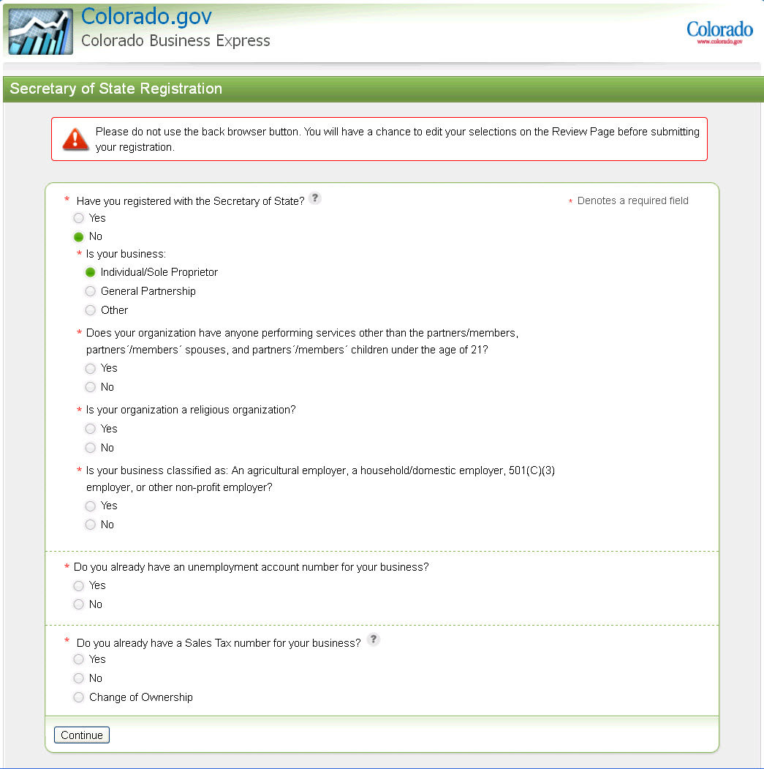

Questions along with an explanation:

Have you registered with the Secretary of State?
All businesses except Individual/Sole Proprietor and General Partnership must be registered with the Secretary of State in order to continue with CBE. If a user says No to this question and then selects ‘Other’ for the follow up question, no matter what the other responses are, they will be directed to register with the Secretary of State before continuing through CBE.
Does your organization have anyone performing services other than the partners/members, partners’/members’ spouses, and partners’/members’ children under the age of 21?
If a user answers No to this question, they will be exited from the Employee path. This is because the business may not be liable to pay unemployment insurance premiums in this situation and should contact the Department of Labor and Employment to find out.
Is your organization a religious organization?
If a user answers Yes to this question, they will be exited from the Employee path. This is because the business may not be liable to pay unemployment insurance premiums and should contact the Department of Labor and Employment to find out.
Is your business classified as: An agricultural employer, a household/domestic employer, 501(C)(3) employer, or other non-profit employer?
If the user answers Yes to this question, they will be exited from the Employee path. This is because the business may not be liable to pay unemployment insurance premiums and should contact the Department of Labor and Employment to find out.
Do you already have an unemployment account number for your business?
If the user answers Yes to this question, they will be removed from the Employee path. This is because they already have an unemployment account number. This will also mean that the business cannot file online for a wage withholding account.
Do you already have a Sales Tax number for your business?
If the user answers Yes to this question, they will be removed from the Sales Tax path. This is because they already have a sales tax account. Answering No or Change of Ownership will continue the users down the Sales Tax path, with the assumption that Change of Ownership will be registering under a different FEIN than the previous owner.

Business Search Page
The Business Search page is only viewed when the user says they are registered with the Secretary of State. This page is to search for the business/trade name and the system will return results from the Secretary of State’s database. This allows for some information to be pre-populated on the next page.

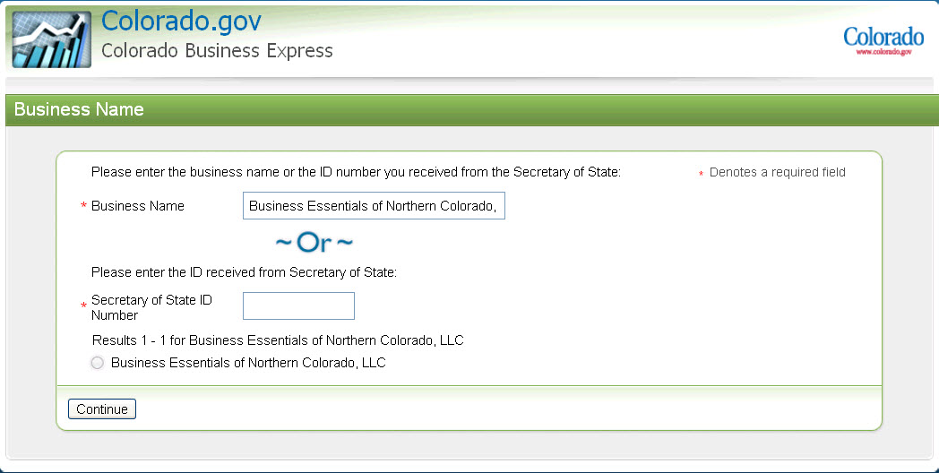

Business Name:
This is where the user should type in the business or trade name. Click Continue and the system will return the possible search results for the user to select. Click Continue again and the system will advance to the next page.
Secretary of State ID Number:
This is where the user should type in their Secretary of State ID Number (if Business Name was not populated). Click Continue and the system will return the possible search results for the user to select. Click Continue again and the system will advance to the next page.

Business Organization Information Page
The Business Organization Information page is a series of fields about the business and the location(s) of the business. Please note that businesses must have an FEIN in order to apply for an unemployment account number and wage withholding account. All businesses except Individual/Sole Proprietor must have an FEIN to apply for a sales tax account. Individual/Sole Proprietor businesses can use a Social Security Number to apply for a sales tax account, but not an unemployment insurance account or wage withholding account.

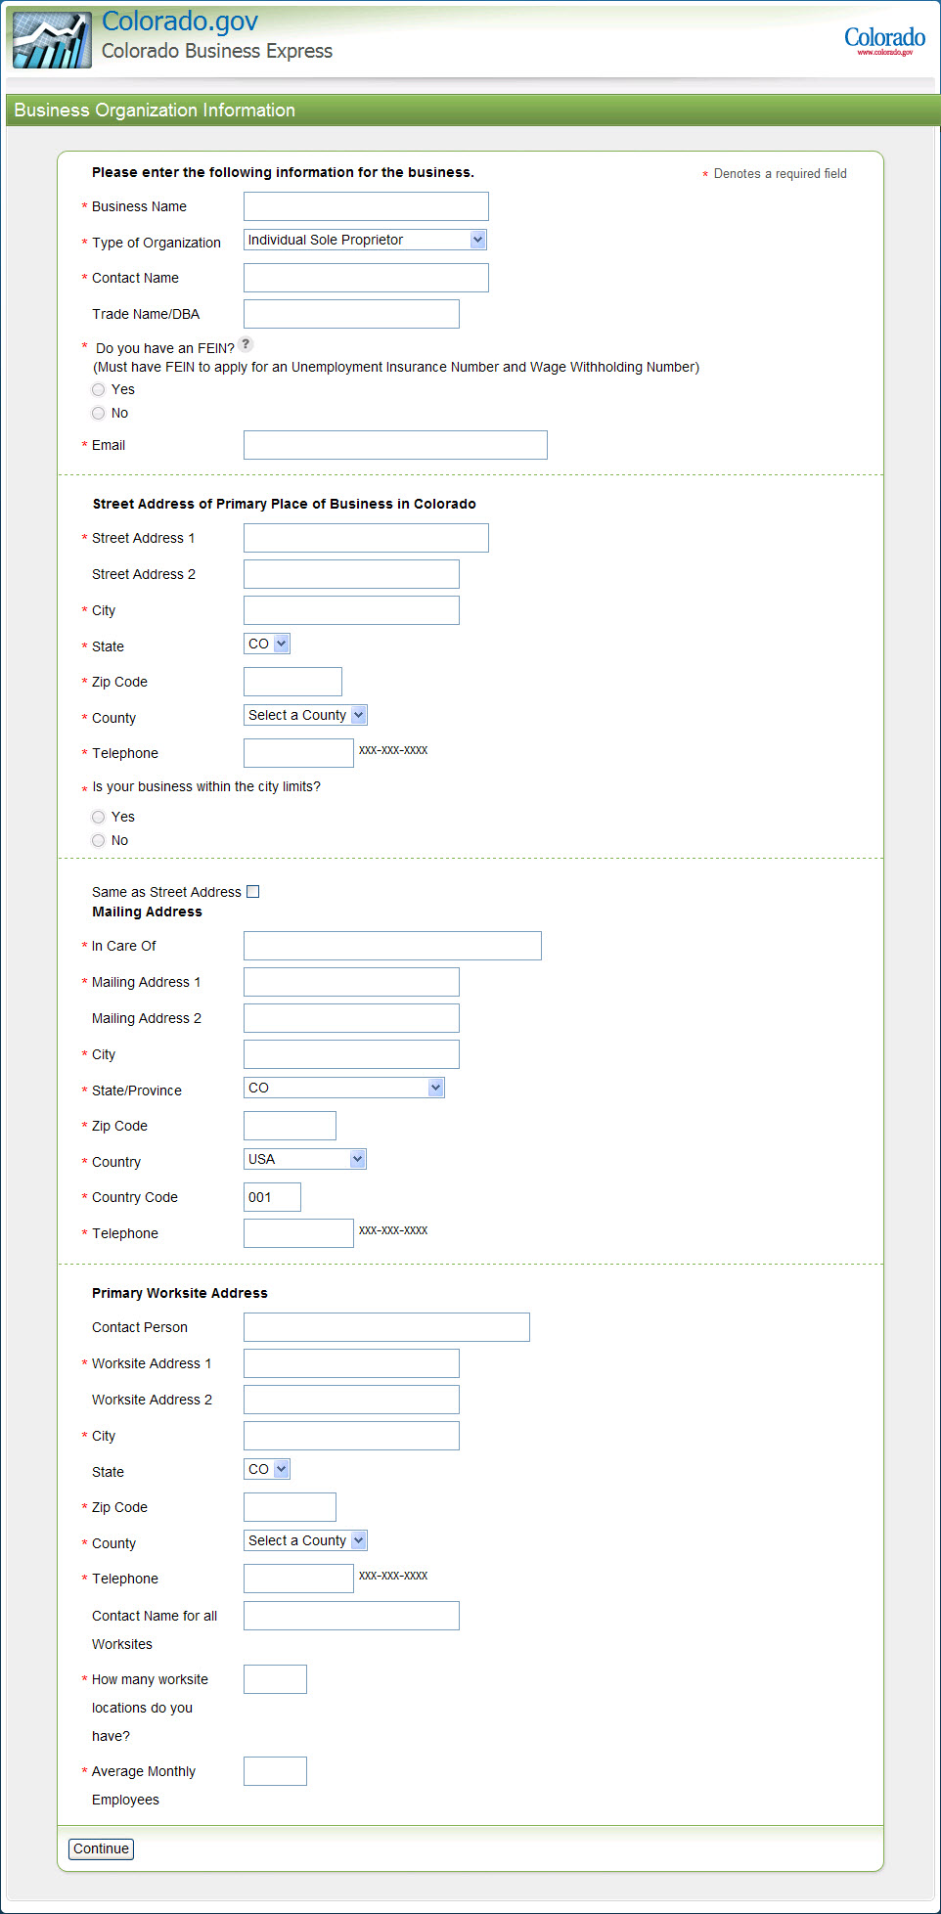

Do you have an FEIN?
Businesses must have an FEIN in order to apply for an unemployment account number and wage withholding account. All businesses except Individual/Sole Proprietor must have an FEIN to apply for a sales tax account. Individual/Sole Proprietor businesses can use a Social Security Number to apply for a sales tax account, but not an unemployment insurance account or wage withholding account.
Primary Worksite Address fields:
This section will only be present on this page if the business is applying for an unemployment insurance account. If on the sales tax path only, this section will not be seen.

Owners, Partners, and Corporate Officers Page
The Owners, Partners, and Corporate Officers page is to collect all owners, partners, and corporate officers contact information. Users can enter up to 7 owners. The system will not take more than 7 owners.

What to do if a business has more than 7 owners:

For Employee Path:
Contact Unemployment Insurance Employer Services at employer.services@state.co.us

For Sales Tax Path:

Mail additional information to:
Colorado Department of Revenue
Attn: BTAS Room 208
Denver, CO 80261

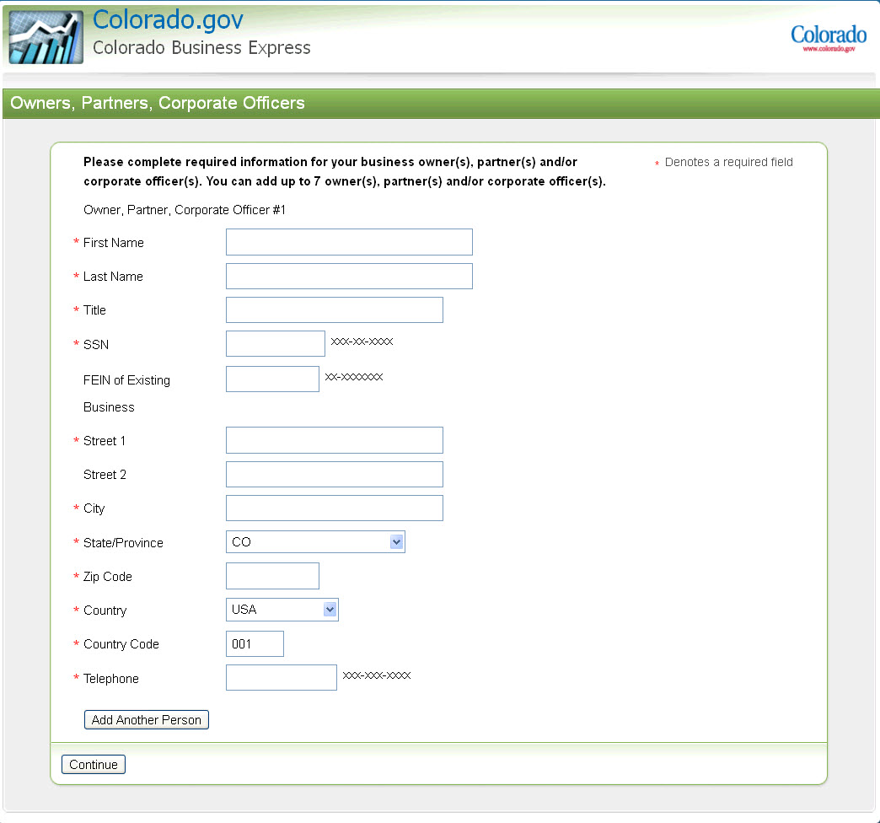

SSN:
This SSN is for the specific owner being entered. This is required unless a business entity is provided on this page as the owner and an FEIN is entered in the next field.
FEIN of existing business:
This FEIN is entered if a business entity is provided as the owner, and it must be a different FEIN than the one entered on the previous page. FEIN and SSN are not both required – users need to enter one or the other.

Employee Page
The Employee page will only be presented to users on the Employee path for an unemployment insurance account or wage withholding account. Users on the sales tax path only will not see this page.

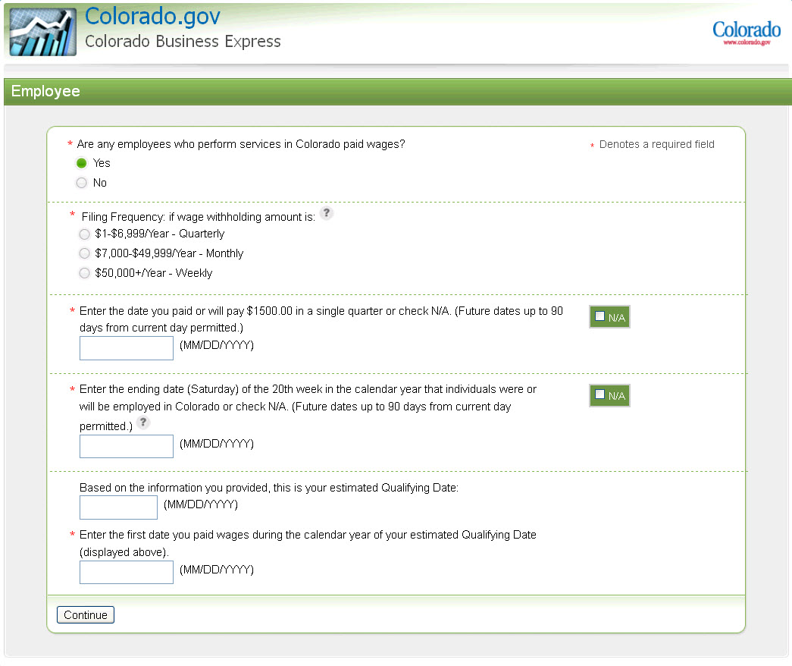

Are any employees who perform services in Colorado paid wages?
If the user selects No to this question, there will not be any follow up questions. The user will be exited from the Employee path once they click Continue and not be able to continue registering for an unemployment insurance account or wage withholding account.
Filing Frequency: if wage withholding amount is:
The business should select what amount applies to their business for wage withholding. Note that the amounts are for the estimated withholding amount, not the actual wages paid. If the user needs assistance figuring this out, they can click on the ‘?’ for more information.
Enter the date you paid or will pay $1500 in a single quarter or check N/A.
If the user does not have a date to put in this field, they can click N/A. Please note, that a date must be entered in either this field or the next field in order to populate the qualifying date. If there is no date entered in either field, the user will be exited from the Employee path for an unemployment insurance account or wage withholding account.
Enter the ending date (Saturday) of the 20th week in the calendar year that individuals were or will be employed in Colorado or check N/A.
If the user does not have a date to put in this field, he or she can click N/A. Please note that a date must be entered in either this field or the previous field in order to populate the qualifying date. If there is no date entered in either field, the user will be exited from the Employee path for an unemployment insurance account or wage withholding account.

If the user needs additional details on how to determine the date to enter in this field, he or she can click the ‘?’ to obtain the following information:

If you’ve employed one or more workers for some portion of a day in 20 different calendar weeks during the current or preceding calendar year (all 20 calendar weeks must occur within the same calendar year), enter a date here. Because, for our program purposes, calendar weeks end on Saturday, you must enter the Saturday date of the 20th week you employed one or more workers. NOTE: The services do not have to be performed in consecutive weeks or by the same employee.

Example of available dates for this field:

May 15, 2010 and each Saturday thereafter in 2010
May 14, 2011 and each Saturday thereafter in 2011
May 12, 2012 and each Saturday thereafter in 2012
May 11, 2013 and each Saturday thereafter in 2013

Based the information you provided, this is your estimated Qualifying Date:
This date is populated by the system. If this date is earlier than the calendar year preceding the calendar year in which the registration is occurring, the user will be exited from the Employee path for an unemployment insurance account or wage withholding account. For example, if the user is registering on 10/21/2011, any Qualifying Date before 1/1/2010 would exit the user from the Employee path.

Bank Information Page
The Bank Information page is for the Employee path only. Users on the Sales Tax only path will not see this page.

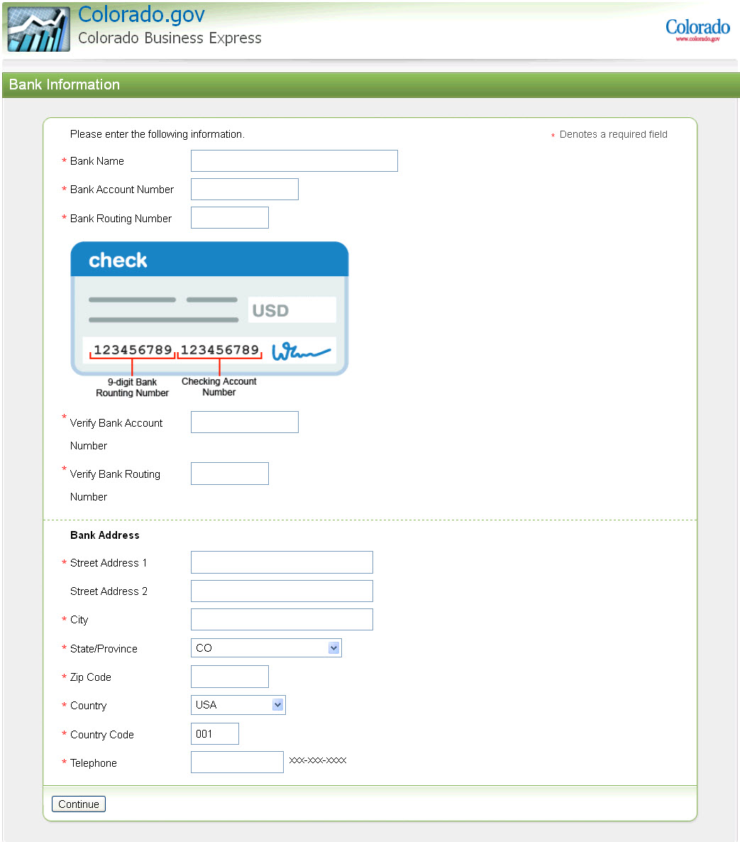

If someone is questioning why this information is collected, please use the following information:

Bank information is securely stored and could be used, in compliance with state laws, if an employer’s unemployment-insurance account becomes delinquent.

Applicable statutes include Colorado Employment Security Act 8-79-102 thru 8-79-105.

If an employer requests more details about the delinquent-account process, please refer him or her to us at:

Unemployment Insurance Employer Services
employer.services@state.co.us
303-318-9100 (Denver-metro area)
1-800-480-8299 (outside Denver-metro area)

Payroll Information Page
Payroll Information page is for the Employee Path only. Users on the Sales Tax path will not see this page.

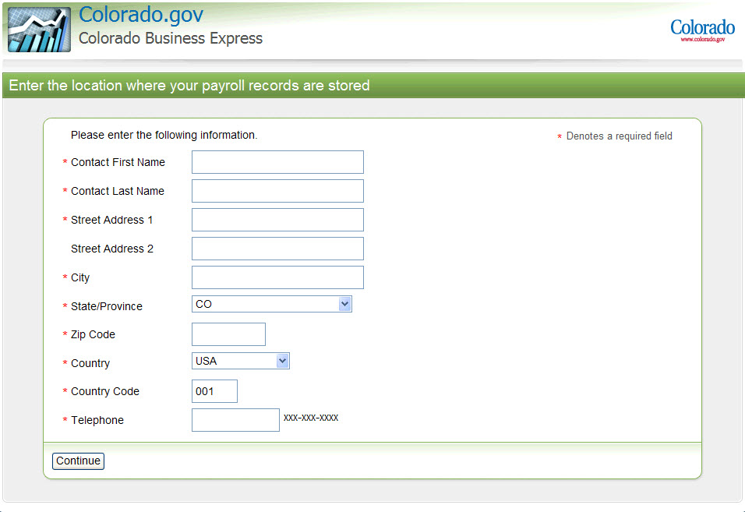

Contact First Name/Contact Last Name:
This field is to collect a contact name for the location that payroll records are located at.

Products and Services Page
The Products and Services page is viewed by both paths. This is to collect what the business provides.

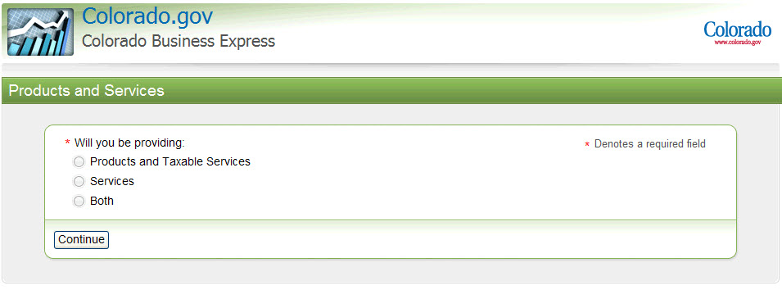

Products and Taxable Services:
Most goods and some services sold in Colorado are taxable and will require a sales tax license. Please check with the Department of Revenue and your local government to get an updated list of goods exempt from sales tax. Users will continue down the Sales Tax path to select the appropriate sales tax license, including Retailers Use and Wholesale license types.
Services:
If a business provides services only, they will be exited from the Sales Tax path and asked to contact the Department of Revenue.
Colorado generally does not impose state sales or use tax on services.
Exceptions to this rule do exist. They include:
- Sales tax upon telephone, gas and electric services,
- Service charges that become an integral part of a taxable item prior to the sale,
- Upholstery charges,
- Rooms and accommodations.

Both:
Examples include a service provider who also sells good, such as a physician who also sells supplements. Users will continue down the Sales Tax path to select the appropriate sales tax license.

Type of Products and Services Page
The Type of Products and Services page is where the user selects the NAICS code appropriate for their business. Users can search by keyword for the code or they can expand sections to select the code that best suits their business.

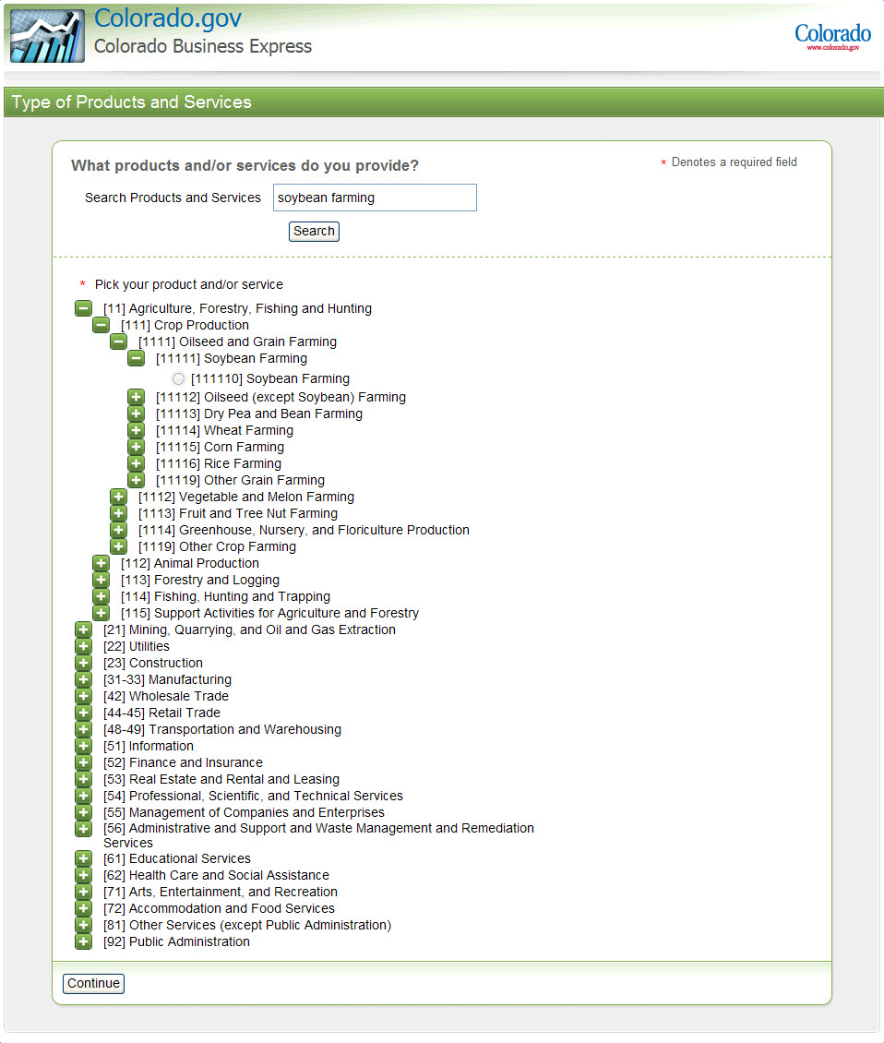

Products and Services Details Page
The Products and Services Details page asks additional questions based on the selection on the previous page. Questions on this page will vary based on the NAICS code selection.

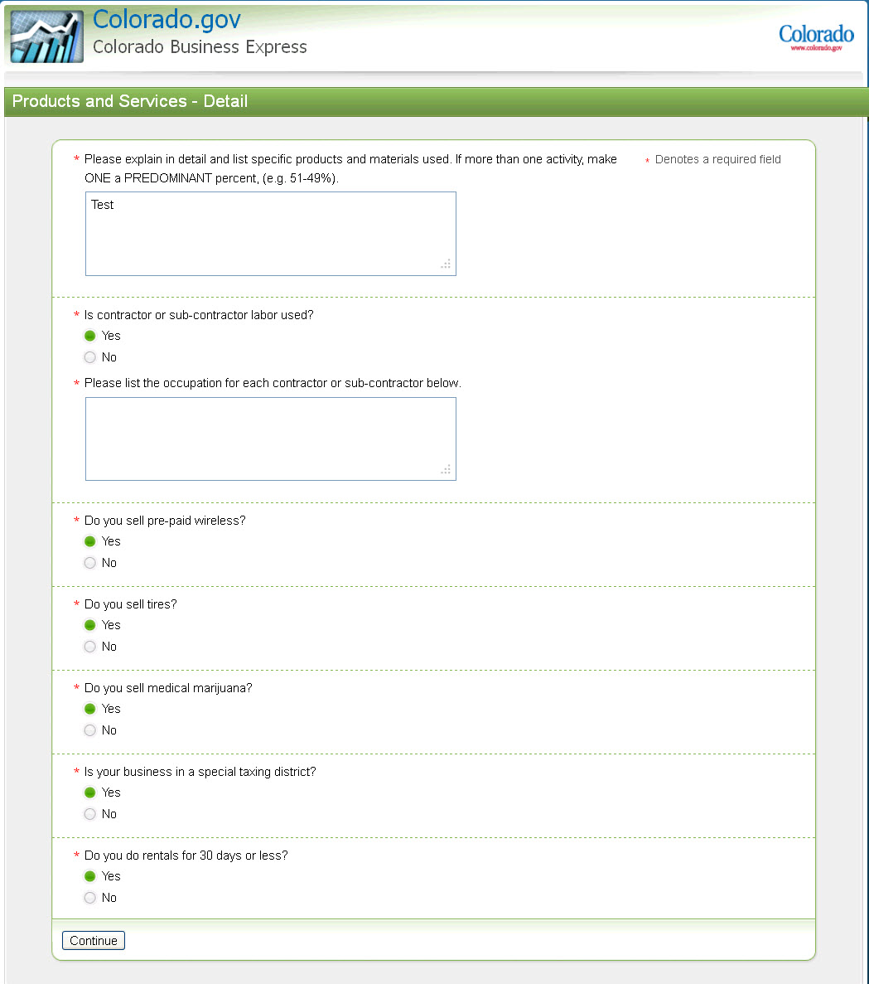

Seasonal Business Page
The Seasonal Business page is viewed by both paths. If the business is seasonal, the user should click Yes and then check the months the business is open.

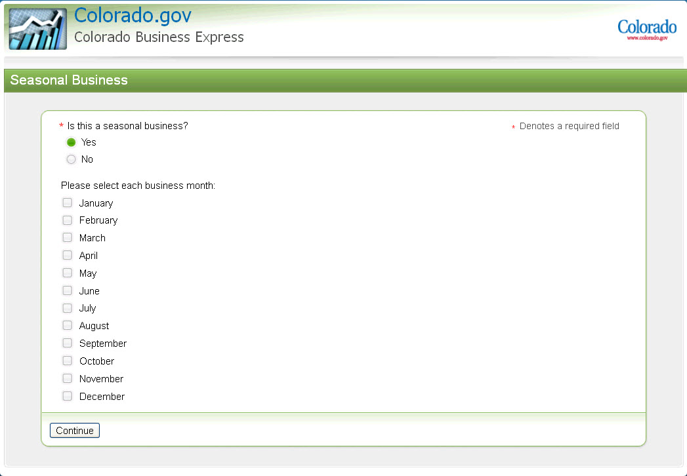

Please note: If on the Sales Tax path and a business is seasonal, they will be required to choose Monthly for their sales tax filing frequency (on the next page), unless they are wholesale business.

Sales Tax Frequency Page
The Sales Tax Frequency page is for the Sales Tax path only. This is to collect the type of sales tax license the business is filing for and the frequency of sales tax payments. If users have questions on how to answer these questions, they can refer to the ‘?’ to guide them through.

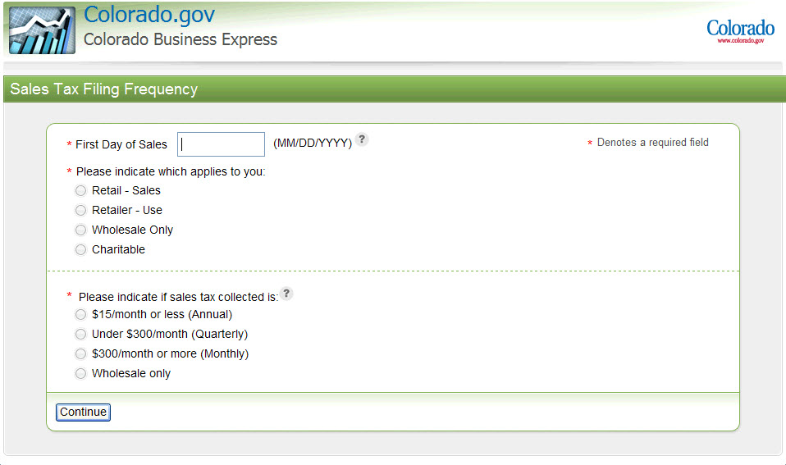

Sales tax filing frequency is based upon the state sales tax amount collected, not gross sales. Refer to the ‘?’ for a chart that will assist users in selecting the appropriate filing frequency.

Due Dates
Sales tax returns are generally due the 20th day of month following reporting period. If the 20th day falls on a weekend or holiday, the due date is the next business day.
- Annual - January 20
- Monthly - 20th day of month following reporting period
- Quarterly:
  - January - March: due April 20
  - April - June: due July 20
  - July - September: due October 20
  - October - December: due January 20

Review Page
The Review page is for users to see what they answered in each section and go back to edit anything that is incorrect. By clicking on ‘Expand’ and ‘Collapse’ users can show and hide their responses. Please note that by changing some answers, users could be prompted through to re-answer some questions or could potentially be exited from a path based on the change.

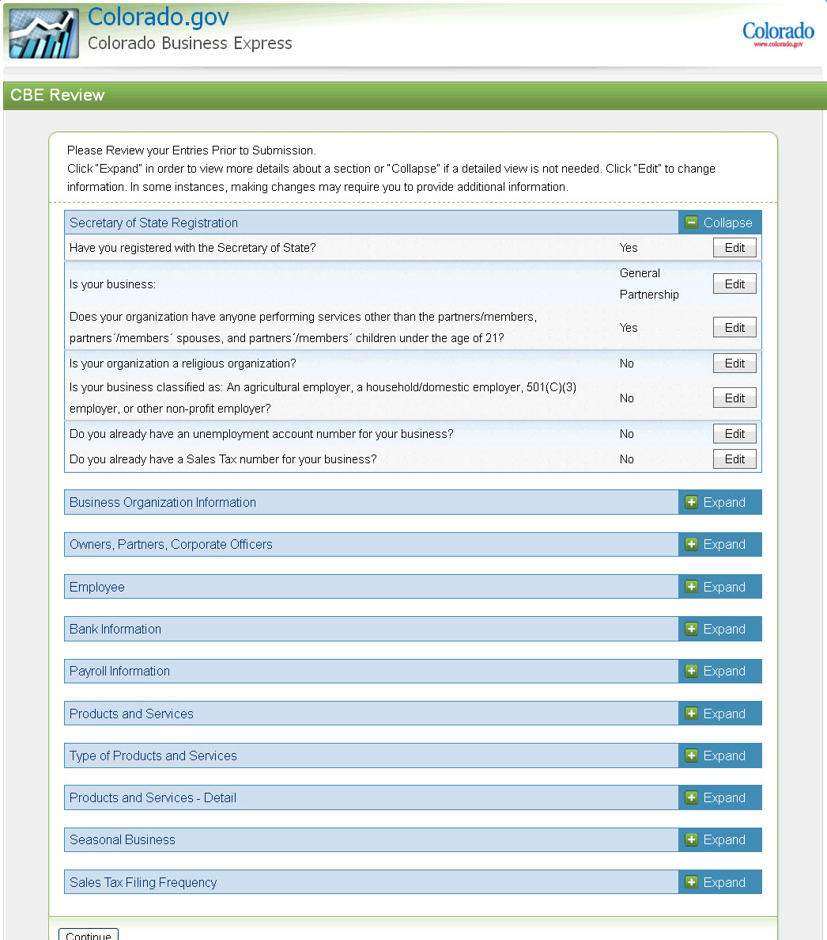

Signature and Disclaimer Page
The Signature and Disclaimer page is so the user can certify/acknowledge the disclaimers and sign.

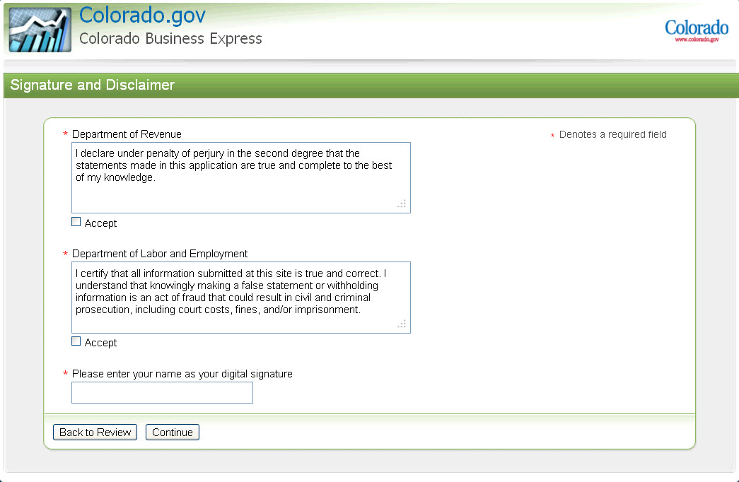

File Now Page
The File Now page is where the user actually submits the filing. The summary will show which agencies the user is filing with and any fees associated if applicable. Fees for a retail sales or wholesale license are:
- If Jan-Jun 2010, 2012, 2014 then the fee = $16.00
- If Jul-Dec 2010, 2012, 2014 then the fee = $12.00
- If Jan-Jun 2011, 2013, 2015 then the fee = $8.00
- If Jul-Dec 2011, 2013, 2015 then the fee = $4.00
- If the user has selected Charitable License then the fee = $8.00
- There is no fee for a Retailers Use license.
- Retail Sales Tax License requires a deposit of $50.00. The $50 deposit will be refunded automatically after a business has collected and paid $50 in state sales taxes. Taxpayers should NOT deduct the deposit on their sales tax return

By clicking on File Now, the system will complete the filings. If there are fees associated with the filing, the system will advance to the first page of Checkout. Registration will not be completed until users submit a payment.

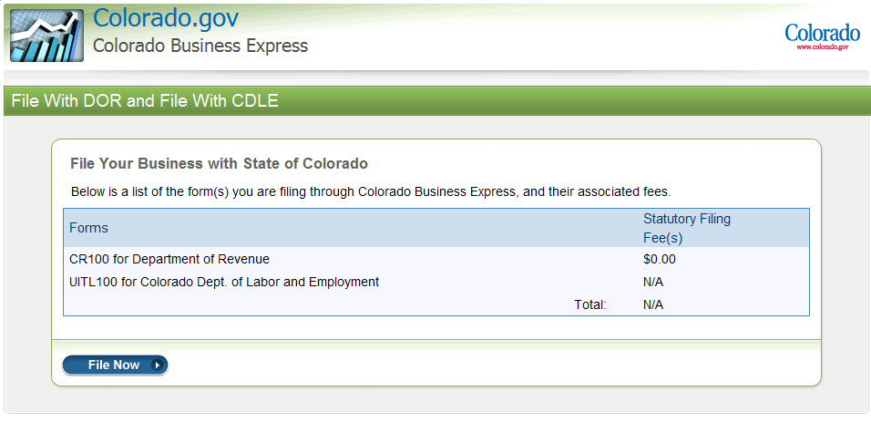

Checkout Utility
The Colorado.gov Checkout Utility is an application that interfaces with the project application to provide payment processing. This self-contained module accepts defined, application-specific data as well as payment information in order to finalize a financial transaction and produce a receipt page.

Credit Card information
Enter the card type (Visa, MasterCard, Discover, or American Express) via the drop down, card number, and expiration date before continuing. Click ‘Continue’ at the bottom of the page and the system will advance you to the Account Holder entry page.
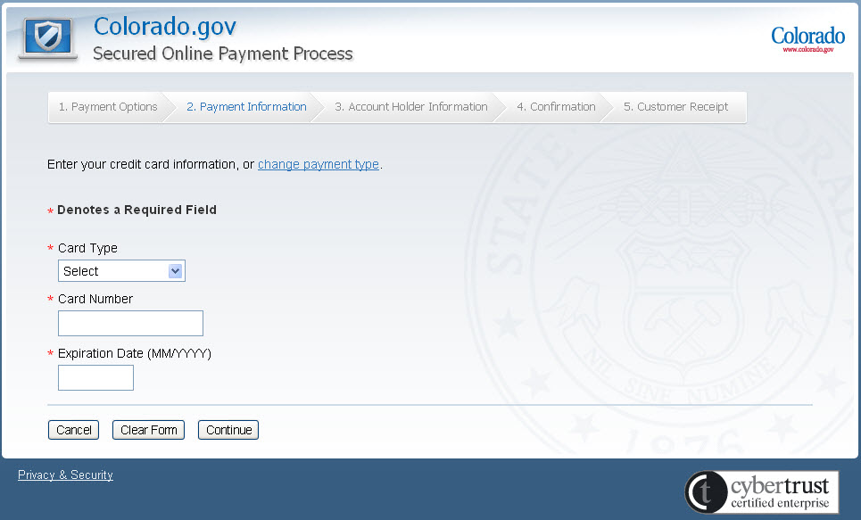

ECheck Information
The account type, routing number, and account number are needed before you may continue. The routing number and account number is required a second time towards the bottom of the page. This will help ensure that no entry error has occurred causing bounced checks.

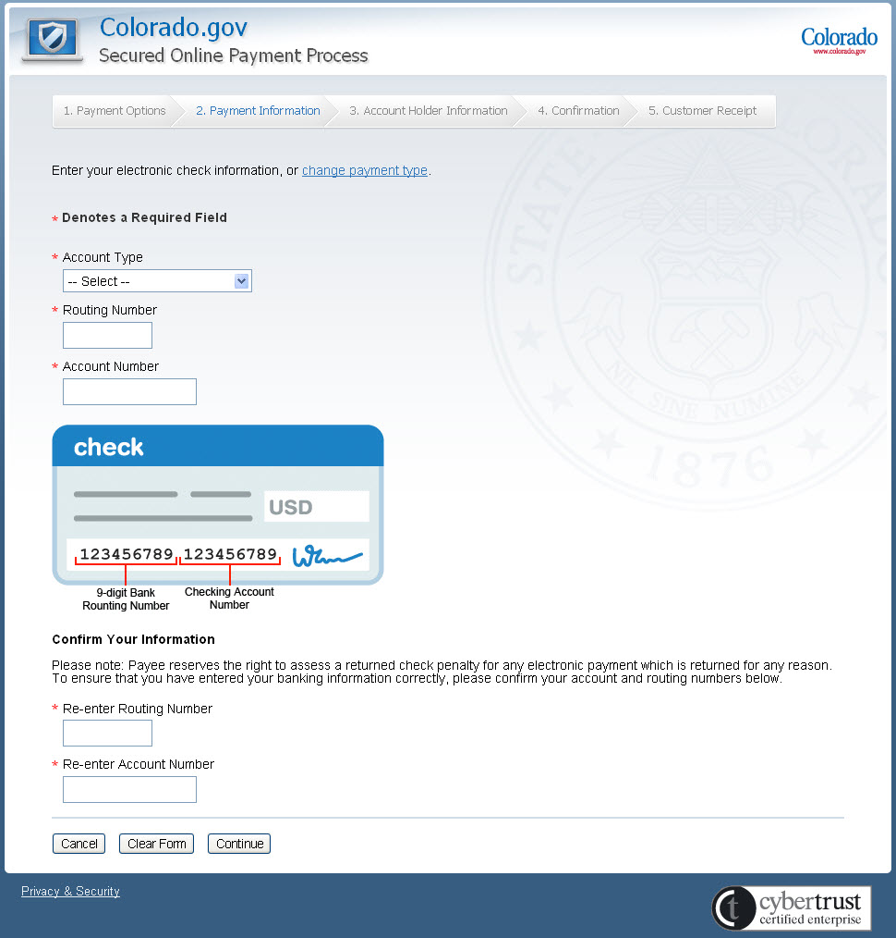

Customer Payment Information
Once test billing information has been added, click ‘Continue’ at the bottom of the page and the system will advance you to the Confirmation page.
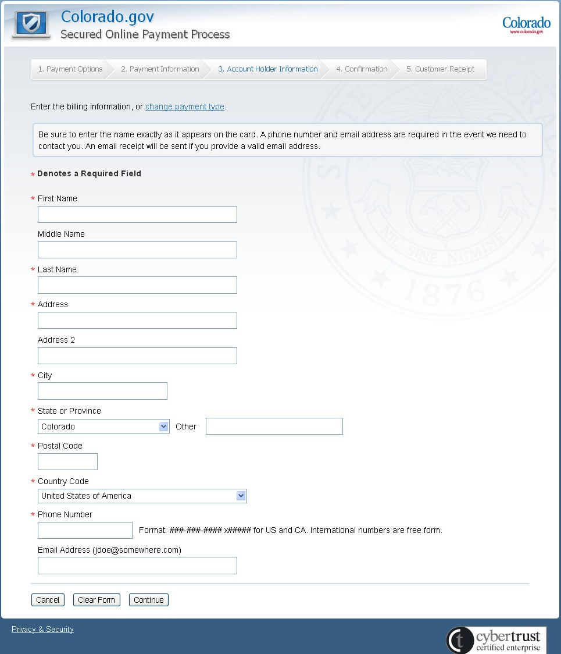

Verify Bank/Credit Card Billing Information
The Billing and Query Disclosure allows the User to view and edit the data collected through the payment process. Users are given the option to agree or disagree to the charges and information presented on this page. Once the User clicks “I Agree”, the payment transaction is processed. Selecting the “I Disagree” control will abort the process and redirect the User to the “Transaction Cancellation Confirmation” page

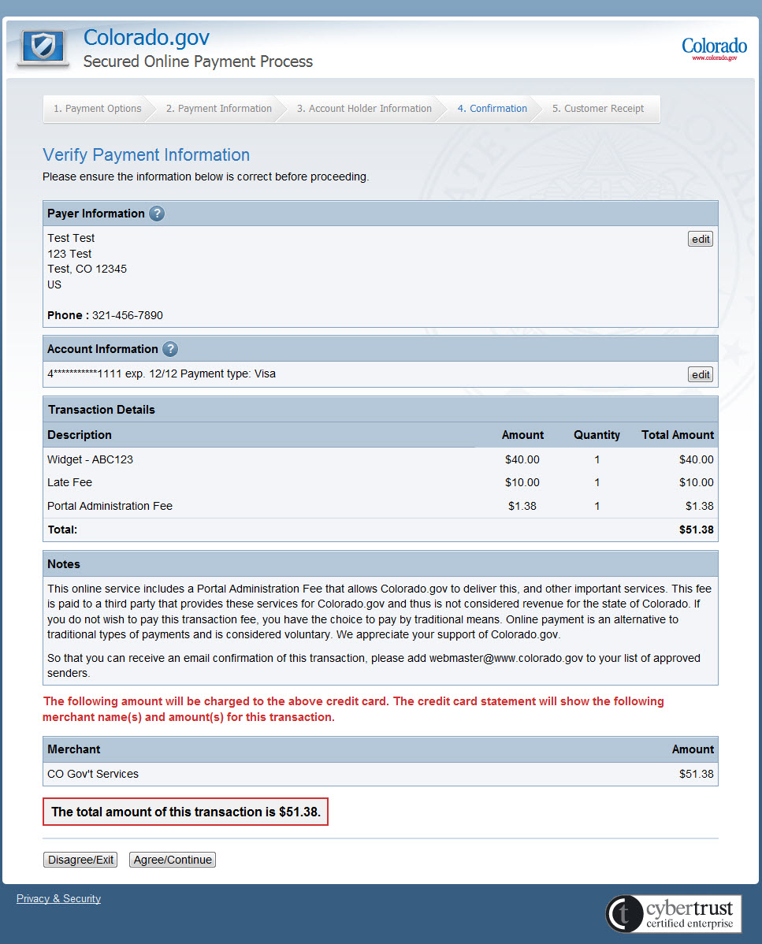
At this point, the credit card is being validated and processed. It could take up to sixty seconds to complete this procedure (click the refresh link if the 60 seconds has elapsed).
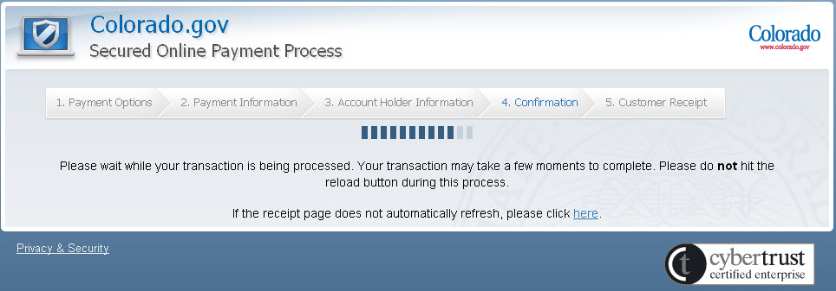

Once the payment has processed, the system will return to the CBE application for the confirmation page.

Confirmation Page
If the user is on the Employee Only path or does not need to go through checkout, the system will automatically advance to the Confirmation page from the File Now page. If the user goes through checkout, the system will advance to this page after the payment is made.

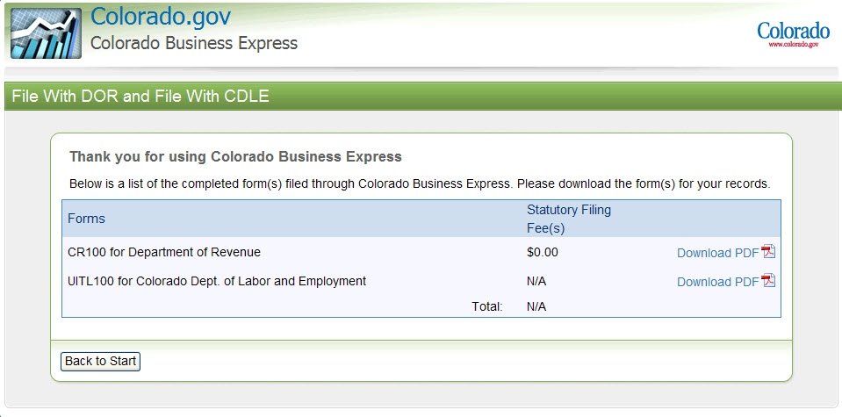

Users can download a copy of their filing by clicking on Download PDF. The PDF will contain their new account information and the questions and answers from their interview. If a user registered for a sales tax license, the Department of Revenue PDF will serve as a temporary sales tax license until their actual license arrives in the mail 7 to 10 business days later.

Example Exit Pages
Below are some examples of exit pages in the application. Each exit page will let you know which agency path you are being removed from and an explanation of why. The page will also list who to contact with questions.

CDLE and DOR exit page:

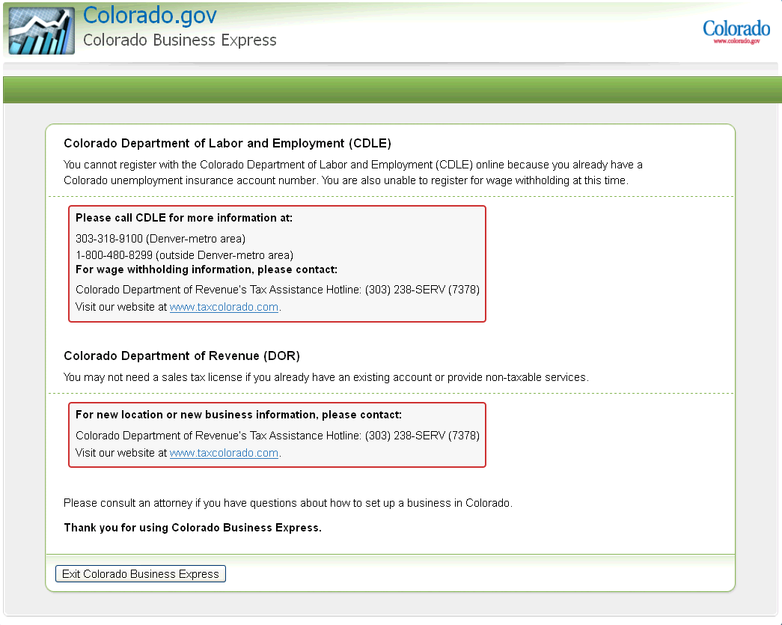

Sales Tax exit:
Please note that you can still continue down the Employee Path in the exit page below. Please be aware of what message you get because the user might be able to continue through the application.

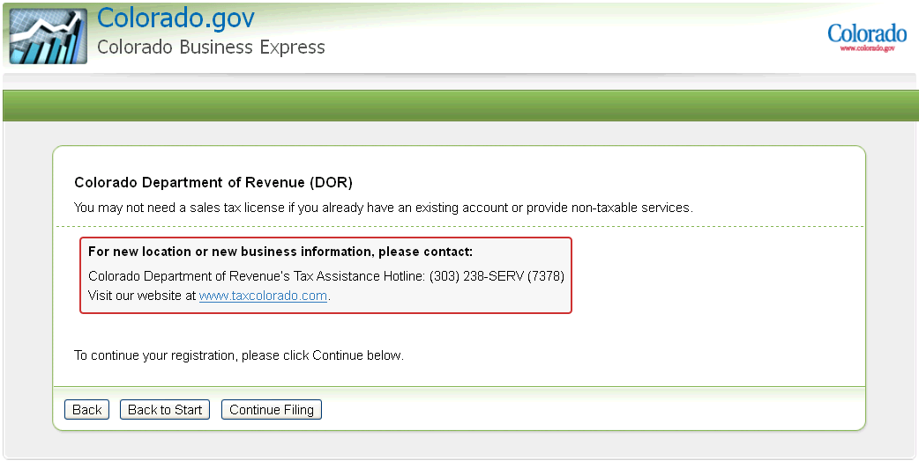

Employee Path exit:

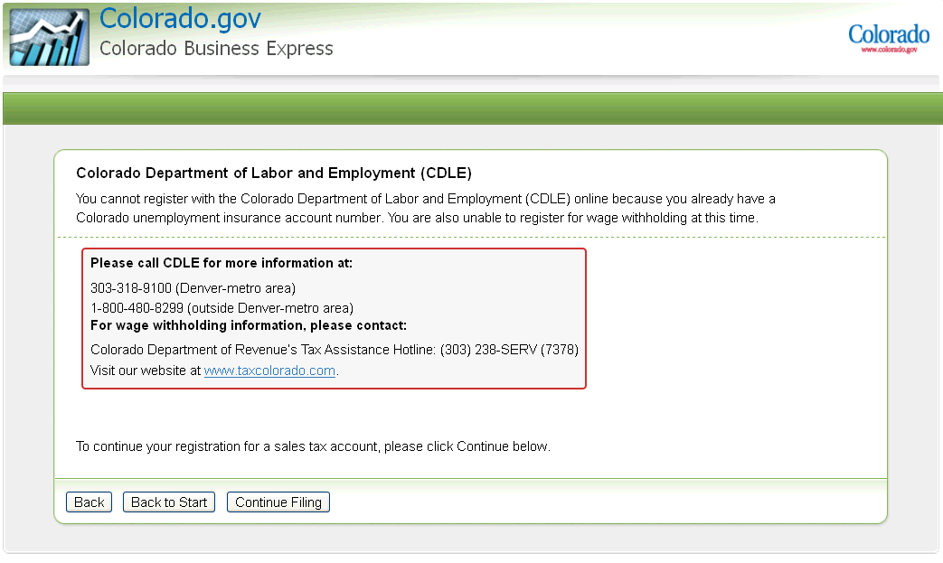

If there are technical issues, you will see an exit page informing you that the system is experiencing technical issues along with contact information.

Who to contact with questions
If you have technical difficulties or questions about the CBE website or application, please contact:

support@www.colorado.gov

If you have questions about filing for an unemployment insurance account, please contact:

Colorado Department of Labor and Employment:
303-318-9100 (Denver-metro area)
1-800-480-8299 (outside Denver-metro area)
- employer.services@state.co.us

If you have questions about filing for a sales tax license or wage withholding account, please contact:

Colorado Department of Revenue:
Colorado Department of Revenue’s Tax Assistance Hotline: (303) 238-SERV (7378)
Or www.taxcolorado.com

